





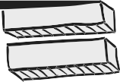






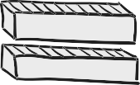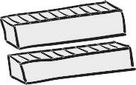

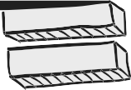
INSTRUCTOR’S MANUAL

QUANTITATIVE RESEARCH METHODS
 FOR COMMUNICATION
A Hands-On Approach



4th Edition


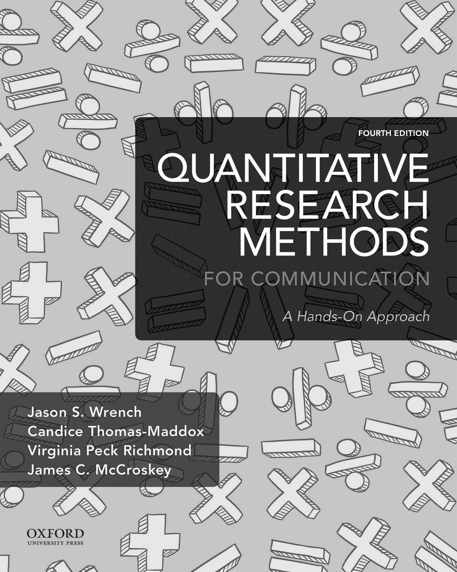

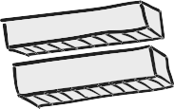

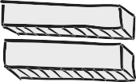



Student Workbook to accompany

Quantitative Research Methods for Communication: A Hands-On Approach

4th Edition

Jason S. Wrench
State University of New York at New Paltz

Candice Thomas Maddox
Ohio University Lancaster

New York Oxford

Oxford University Press

Introduction
The following student workbook has been designed to help you prepare to teach a course in quantitative research methods using Jason S. Wrench, Candice Thomas- Maddox, Virginia Peck Richmond, and James C. McCroskey’s Quantitative Research Methods for Communication: A Hands-On Approach (4th edition) published by Oxford University Press. The student workbook is designed to give students outlines that will help them take notes when reading the book itself.

The workbook is designed to give you an overview of the textbook itself. This workbook should not be used to take a course in quantitative research methods alone. The textbook serves as the primary source of information for this manual, so the outlines in this manual correspond directly with the material in the book.

This workbook is a skeletal outline of the content covered within the textbook. We understand that when reading textbooks, students are often unsure of what they should be picking out of the text. To help you understand our logic in the text, we encourage you to follow this outline while reading the book. You can add space on the outline to help you take notes while reading. If your professor follows the text closely, you can print out the outline, bring it to class, and take notes on the outline. We hope that this workbook will help you further understand the quantitative research process.

Lastly, we have completely revamped the Student Workbook along with a host of other the student materials for this edition of the textbook. We really wanted to expand everything that we offer students, so please make sure you check out all of the items located on our new website: https://oup-arc.com/wrench.

Sincerely,

Jason S. Wrench, State University of New York at New Paltz
Candice Thomas-Maddox, Ohio University Lancaster
Virginia Peck Richmond, University of Alabama at Birmingham
James C. McCroskey, University of Alabama at Birmingham

Chapter 1

An Introduction to Communication Research
- Explain the difference between physical and social sciences.
- Describe the history of social sciences and its relation to the field of communication.
- Define the term communication.
- Explain Claude Shannon and Warren Weaver’s (1949) model of communication.
- Understand the basic layout of this textbook.

I. Physical vs. Social Sciences

A. Physical Sciences

B. Social Sciences

II. History of Social Science

A. The Ancient Greeks

1. Hippocrates of Cos

2. Plato

3. Aristotle

B. Division between Physical and Social Sciences

1. Sir Isaac Newton

2. Charles Darwin

3. Ernest Rutherford

C. Late 1800s to Early 1900s – Communication as a Social Science

1. Communication focus

a. James A. Winans

b. Everett Lee Hunt

2. Social Sciences after World War I

a. Development of attitude research

b. Areas of attitude research

c. Measures of attitudes

3. Social Sciences during World War II

a. Creation of the U.S. Office of War Information

b. Categories of communication (Lazarsfeld – 1944)

4. Post-World War II Research

a. Yale University studies - Carl Hovland

b. William Schramm and David Berlo

5. Contemporary Perspectives of the Social Sciences

III. Communication

A. Defined: Process by which one person stimulates meaning in the mind(s) of another person (or persons) through verbal and nonverbal messages.

1. Process

2. Stimulating meaning

B. Claude Shannon and Warren Weaver Communication Model (SMCR)

1. Sender

2. Encoding

3. Message

4. Receiver

5. Decoding

6. Channel

a. Language / Verbal messages

b. Nonverbal messages

c. Mediated channel

C. Communication vs. Communications (with an “s”)

IV. Format of the Textbook

A. Aspects of communication research

B. Research process

C. Fundamental parts of research projects

D. Techniques for conducting research

E. Basic concepts in research methods

F. Statistical analysis and tools

G. Application and understanding of research questions

Chapter 2
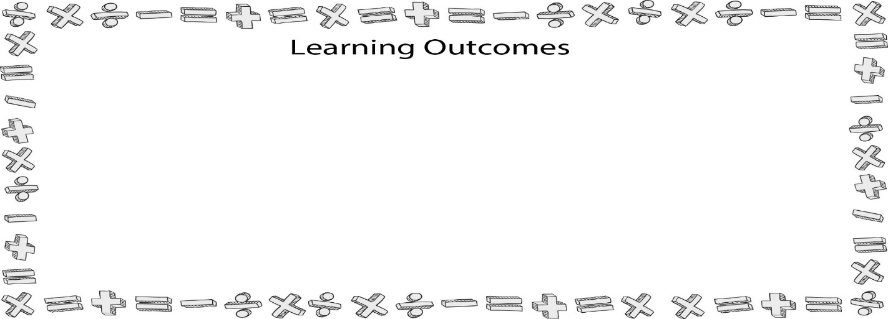
Empirical Research
- Define the term research.
- Describe the different epistemological approaches to communication scholarship.
- Understand the basic processes involved in the modern scientific method.
- Recognize and construct logical arguments.
- Explain what empirical generalizations are and why they are important to the scientific processes.

I. What is Research?

A. Research defined

B. Epistemological approaches to research

1. Epistemology defined: A way of knowing.

2. Klein’s (2002) three important questions

a. How does one analyze knowledge and justification?

b. What sources of knowledge does one use?

i. Social scientific

ii. Interpretive

iii. Critical

c. What is the importance and use of skepticism?

3. Ordinary vs. scientific ways of knowing

a. Ordinary sources of information

i. Traditions

ii. Authority figures

b. Problems with ordinary knowledge

c. Six differences between ordinary and scientific knowledge

i. Conceptualizing the topic

ii. Reading the literature

iii. Careful measurements

iv. Collecting samples

v. Analyzing data and presenting results

vi. Ethics and politics

II. The Scientific Approach to Communication Research

A. Scientific Method

1. Background

2. Seven basic steps

a. Observation

b. Stating the scientific problem

c. Formulating a hypothesis

d. Testing the hypothesis through experimentation

e. Analyzing the experimental results

f. Interpreting data and forming conclusions

g. Publishing research
3. Theories

a. Defined

b. Describe the natural phenomenon

i. Appeal to authority

ii. Label the phenomena

iii. Evoke empathy

iv. Define terms or give examples

v. Appeal to general empirical rules

c. Predict the future

d. Falsification

4. Predictions/Hypotheses

a. Hypothetical propositions

i. Antecedent
ii. Consequent

b. Argument

i. Major premise

ii. Minor premise

iii. Conclusion

c. Argument formation and research

5. Observations

a. Physical vs. social scientific observations

b. Empirical observations

i. Objective observations

ii. Controlled observations

6. Empirical generalizations

a. Defined

b. Problems with generalizations

i. Hasty generalizations

ii. Ecological fallacies

iii. Exception fallacies

7. Cycle starts over again

Chapter 3
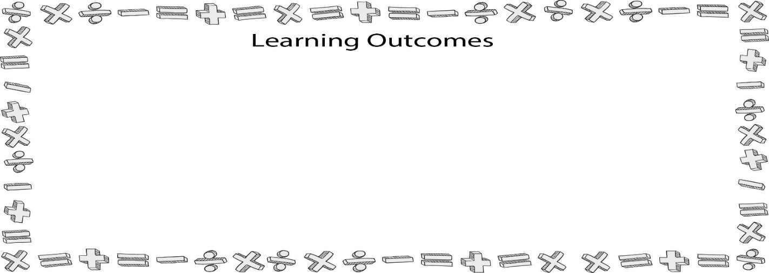
Research Ethics
- Summarize eight actual research studies that have questionable ethical practices.
- Explain the three principles for ethical research spelled out in the Belmont Report.
- Explain the basic purposes for institutional review boards (IRBs).
- Distinguish among anonymity, confidentiality, and privacy.
- Explain the seven specific issues related to research ethics.

I. Historical Cases in Research Ethics

A. Tuskegee Syphilis Study

B. Liquor Store Burglary Study

C. Anonymous Sex in Public Restrooms

D. Wichita Jury Study of 1954

E. Stanford Prison Study

F. Milgram Study
G. Adolescent Alcohol Consumption Project

H. Undercover with Freshman Study

I. Facebook

J. Diederik Stapel

II. Ethics

A. Defined: The study of a means to an end.

B. Four Categories of Ethics

INSERT PICTURE HERE

1. Good means – good end – ethical behavior

2. Bad means – bad end – unethical behavior

3. Bad means – good end – Machiavellian ethic

4. Good means – bad end – subjective ethic

III. The Belmont Report’s Effect on Research Ethics

A. Purpose of the Belmont Report

B. Three Principles for Human Subjects

1. Informed consent

2. Beneficence

3. Justice

IV. Institutional Review Boards

A. The Common Rule

B. IRB Basics

1. Research participant

2. Research participant compensation

3. Anonymity, privacy, and confidentiality

a. Anonymity

b. Privacy

c. Confidentiality

C. Informed Consent

1. Defined

2. Information that must be provided

3. Deception and informed consent

D. IRB Process

1. IRB Membership

2. Functions of an IRB

3. Other possible IRB tasks

E. Levels of Review

1. Exempt

2. Expedited

3. Full board

V. Specific Ethical Issues for Research

A. Data Accuracy

B. Data Sharing

C. Duplicate Data Publication

D. Post Hoc Hypothesis Revisions

E. Participant Identity Disclosures
F. Authorship Credit

G. Plagiarism

1. Defined

2. Source-Not-Cited Plagiarism

a. The ghostwriter

b. The photocopier

c. The potluck writer

d. The disguiser

e. The Self-Stealer

3. Source-Cited Plagiarism

a. The forgotten footnote/reference

b. The misinformer

c. The too-perfect paraphraser

d. The resourceful citer

e. The perfect crime

Chapter Four
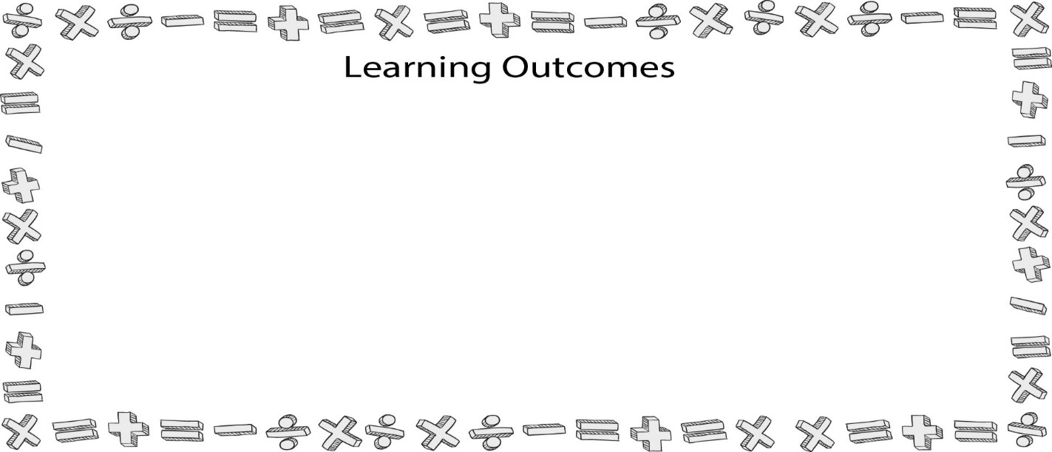
Searching for Previous Research and American Psychological Association (APA) Style
- Understand how researchers identify research topics.
- Understand the different types of academic sources available, explain how to use them appropriately, and describe how to evaluate their worth.
- Understand how to cite sources using the American Psychological Association (APA) style to create a reference page.
- Describe how to internally (parenthetically) cite primary research within your own writing using APA style.
- Understand how to format papers using APA style.

I. Identifying the Topic

A. Why are you doing the research?

B. What interests you?

C. Three possible sources for topics

1. Personal experiences

2. Reviewing the literature

3. Theoretically driven questions

II. Clarifying the Research Question and Generating Key Terms

A. Stating the topic in the form of a research question

B. Identifying key terms and synonymous terms

C. Research Planning Worksheet

1. What is your initial research question(s)?
2. What do you already know about this topic? List any information you currently have about your topic
3. What keywords can you use to assist you in conducting a library search? Be sure to include synonyms for all terms identified!
4. What resources should you examine to begin your review of literature?
ELECTRONIC  DATABASES | WEBSITES | ENCYCLOPEDIAS/  HANDBOOKS
5. Begin your search for information. Be sure to complete a summary sheet for each source you think will be useful for your study!
6. Review and evaluate the information. What did you discover from your research?
What questions have been answered?

What questions remain unanswered?

Should any studies be replicated?

7. Evaluate your sources. Now that the initial research process is complete, revise your initial research question.

III. Locating sources of information

A. Primary vs. secondary sources

1. Primary sources

2. Secondary sources

a. Common problems with secondary sources

b. Backtracking

c. Translation of primary sources

B. Types of information sources

C. Locating information sources

1. Handbooks and subject encyclopedias

2. Electronic databases

a. Finding databases

b. Database searches

c. Boolean logic

d. Truncation symbols

3. The World Wide Web

4. Other online research databases

5. Consult with librarians

D. Evaluating Web Sources

1. Accuracy

2. Authority

3. Currency

4. Objectivity

IV. Organizing and Evaluating Information

A. Use key terms to search for general reference materials

B. Complete a source record card for each source

C. Review the abstract for each source

D. Review the bibliographies for each source

V. Citing Sources of Information Using the APA Format

A. What information must be referenced?

B. Citing sources of information

1. Parenthetical citations

2. Quotations and paraphrases

a. Quotations

b. Paraphrases

VI. APA Paper Formatting

A. Title page

B. Abstract

C. First page

D. Reference page

Chapter Five

Research Structure and Literature Reviews
- Understand the basic information that one should include a study abstract.
- Explain how to write an introduction to a paper.
- Apply the different methods for laying out a literature review.
- Describe the different parts of a method section.
- Explain the basic purposes for both results and discussion sections.

I. Abstract

II. Introduction

A. Attention-getter

1. Using statistics or claims

2. Posing a rhetorical question

3. Using an acknowledged fact

4. Using a story or illustration

5. Quoting or acknowledging a source

B. Link to the topic

C. Identify the significance of the topic

D. Espousal of credibility

E. Thesis

F. Preview

III. Literature Review

A. Five reasons for literature reviews

1. Explaining vocabulary

2. Placing a study in historical context

3. Explanation and Rationalization for variables

4. Previous findings and research needed

5. Establishing your argument

B. Organizing previous research

1. Chronological

2. Cause and effect

3. Compare and contrast

4. Problem-cause-solution

5. Psychological

6. Categorical/topical

a. General to specific

b. Specific to general

c. Known to unknown

IV. Study Rationale

V. Method Section

A. Participants

B. Apparatus

C. Procedure

D. Instrumentation

VI. Results Section

VII. Discussion Section

A. Limitations

B. Future directions for research

VIII. The Conclusion

IX. References and End Materials

A. References

B. End materials

1. Footnotes

2. Tables

3. Figures

X. Reading and Critiquing Academic Literature

A. Are there any key terms that are defined?

B What did the authors state as the purpose of their study?

C. Do the authors have a clear summary of previous research?

D. Do the authors provide a clear critique of previous research?

E. Do the authors clearly identify a gap in the research? Do you note any gaps in the literature that the authors did not identify?

F. What is the rationale for the current study?

G. What are the explicit hypotheses and/or research questions in this study? If there are no explicit hypotheses and/or research questions given, what do you think they are?

H. What was the sample used in this study?

I. How was the sample recruited in this study? Are there any known flaws in this method?

J. Are the demographics of the sample generalizable?

K. What was measured in this study and how? Are there any flaws that you see in how the authors went about measuring?

L. What are the results in this study? What statistical methods were used to achieve these results? Do the statistical methods make sense in the context of this study?

M. Are there any results that seem to be missing?

N. Do the authors explain how the results are consistent with existing literature? Do the authors explain how the results are inconsistent with existing literature?

O. What limitations did the authors mention to their study? Do you note any additional limitations not discussed by the authors?

P. Do the authors discuss any future directions for this line of work? Do you see any additional lines of research that could stem from this study?
XI. Preparing a First Draft of a Literature Review

A. Identify your general topic

B. Determine the type of study you are conducting

C. Determine what variables you will examine

D. Search for primary sources

E. Obtain full text references

F. Look for additional references in obtained materials

G. Narrow your list of references

H. Organize references by major topics and subtopics

I. Identify gaps in your references

J. Find references to fill gaps

L. Write

Chapter Six
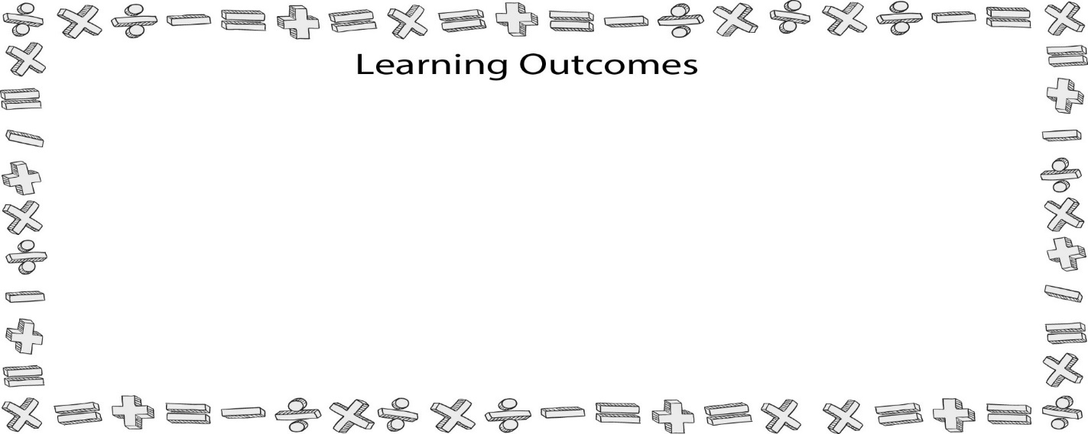
Variables
- Explain the concept of a variable.
- Differentiate between positive, negative, and neutral relationships.
- Differentiate among the four levels of variables (nominal, ordinal, interval, and ratio).
- Explain the four basic types of interval scales (Likert, semantic differential, Staple, and scalogram).
- Apply information from this chapter to write an American Psychological Association (APA) style method section.

I. How Are Research Projects Developed?

II. Variables

A. Concrete

B. Abstract

III. Units of Analysis

A. Individuals

B. Dyads

C. Groups

D. Organizations

IV. Aspects of Variables

A. Attributes

B. Values

C. Understanding relationships and differences

1. Relationships

a. Positive relationship

b. Negative relationship

c. Neutral relationship

2. Differences

a. Differences in kind

b. Differences of degree

c. Statistical differences

V. Types of Variables

A. Independent and dependent variables

1. Independent

2. Dependent / criterion

B. Intervening variables

C. Antecedent variables

VI. Variable Levels

A. Nominal variables

B. Ordinal variables

C. Interval variables

1. Likert scale (Figure 6.6)

2. Semantic differential scale (Figure 6.7)

3. Staple scale (Figure 6.8)

4. Scalogram (Figure 6.9)

D. Ratio variables

VII. Communication Variables

A. Nominal variables

1. Biological sex

2. Political affiliation

B. Ordinal variables

1. University classification

2. Time spent online

C. Interval variables

1. Personality and communication

2. External vs. internal levels

3. Dynamic vs. consistent

4. Traits and communication

a. Traits

b. Contexts

c. Audience

d. Situational

5. Communication trait continuum (Figure 6.11)

D. Communication Apprehension
1. Trait CA

2. Contextual CA

3. Situational CA

E. Ethnocentrism

F. Humor assessment

G. Nonverbal immediacy

H. Sociocommunicative orientation (See Figure 6.16 in text for Sociocommunicative Orientation Scale)

1. Assertiveness

2. Responsiveness

I. Willingness to communicate: (See Figure 6.17 in text for Willingness to Communicate Scale)

J. Beliefs and attitudes

1. Generalized belief scale – See Figure 6.18 in text for scale

2. Generalized attitude measure – See Figure 6.19 in text for scale

3. Beliefs vs. attitudes

a. Beliefs

b. Attitudes

K. Ratio variables – age

VIII. Choosing the Right Test

Interval/Ratio | Differences | Two groups | T-Test
Interval/Ratio | Differences | More than two groups | ANOVA
Interval/Ratio | Relationships | Two variables | Correlation
Interval/Ratio | Relationships | More than two variables | Regression
Ordinal | Differences | Two groups | Mann-Whitney or T-Test
Ordinal | Differences | More than 2 groups | ANOVA
Ordinal | Relationships |  | Correlation
Nominal | Differences |  | Chi-Square
Nominal | Relationships |  | Percentage Differences

IX. Writing Up Scales Using APA Style

A. Participants

B. Apparatus

C. Procedures

D. Instrumentation

E. Sample APA Write-ups

Chapter Seven
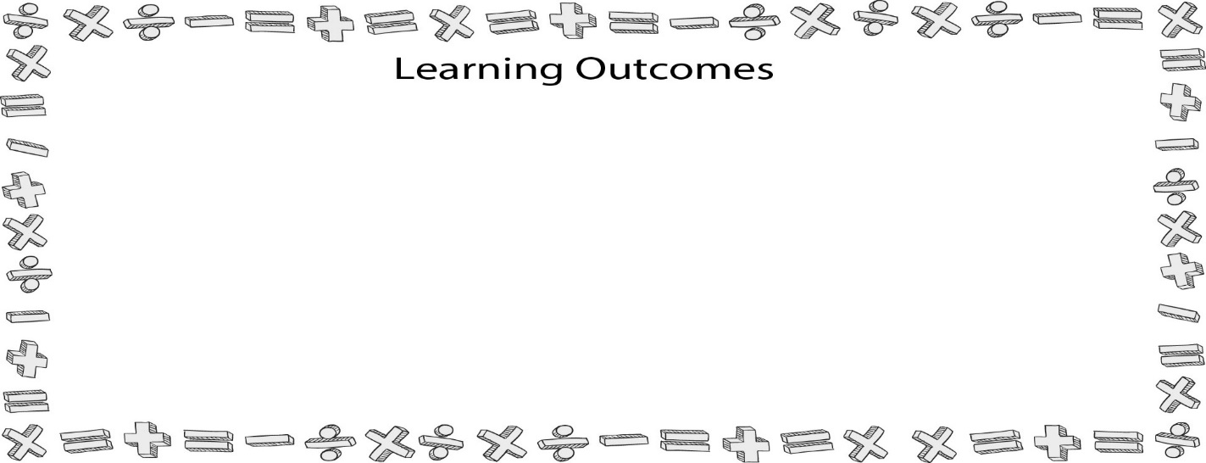
Measurement
- Define the term measurement.
- Discuss the history of measurement in the social sciences.
- Explain the purposes of Likert and semantic differential scales in research.
- Describe the relationship between conceptualization and operationalization.
- Identify the 15 guidelines for writing Likert scale items.
- Distinguish between parametric and nonparametric tests.

I. Measurement: Defining the Term

A. Measuring a line

B. Measurement procedures and rules

II. Numbers and Things

III. Review of Measurement Levels

A. Nominal

B. Ordinal

C. Interval

D. Ratio

IV. A History of Measurement

A. Charles Darwin and Francis Galton

B. James McKeen Cattell

C. Alfred Binet and the Rise of Intelligence Tests

D. Robert Woodworth and the Creation of Personality Tests

E. Emory S. Bogardus’s Social Distance Scale

F. Likert Scales

G. Semantic Differential Scales

V. Measuring Communication

A. Personality traits/states

B. Beliefs and attitudes

C. Knowledge

1. Cognitive knowledge

2. Perceived knowledge

VI. The Process of Creating a New Measure

A. The Germinal Idea

B. Conceptualization

C. Operationalization

1. Putting people into groups

2. Observing existing records/asking people

3. Interviews/surveys

VII. Constructing Questions

A. Start with twice as many items as you will need

B. Every item should reflect the construct

C. Use concise, clearly worded, unambiguous items

D. Construct relatively short items

E. Pay attention to terminology in the item

F. Avoid emotionally charged items

G. Avoid leading items

H. Avoid loaded items

I. Avoid double questions

J. Avoid questions with false premises

K. Avoid using the words “always” and “never”

L. Avoid double negatives/positives

M. Avoid hypothetical questions

N. Avoid ambiguous pronoun references

O. Consider recall issues for certain types of items

VIII. One Measure, Multiple Factors

A. Subscale

B. Factor analysis

IX. Measurement and Statistical Analysis

A. Parameter

B. Nonparametric tests

C. Parametric tests

Chapter Eight
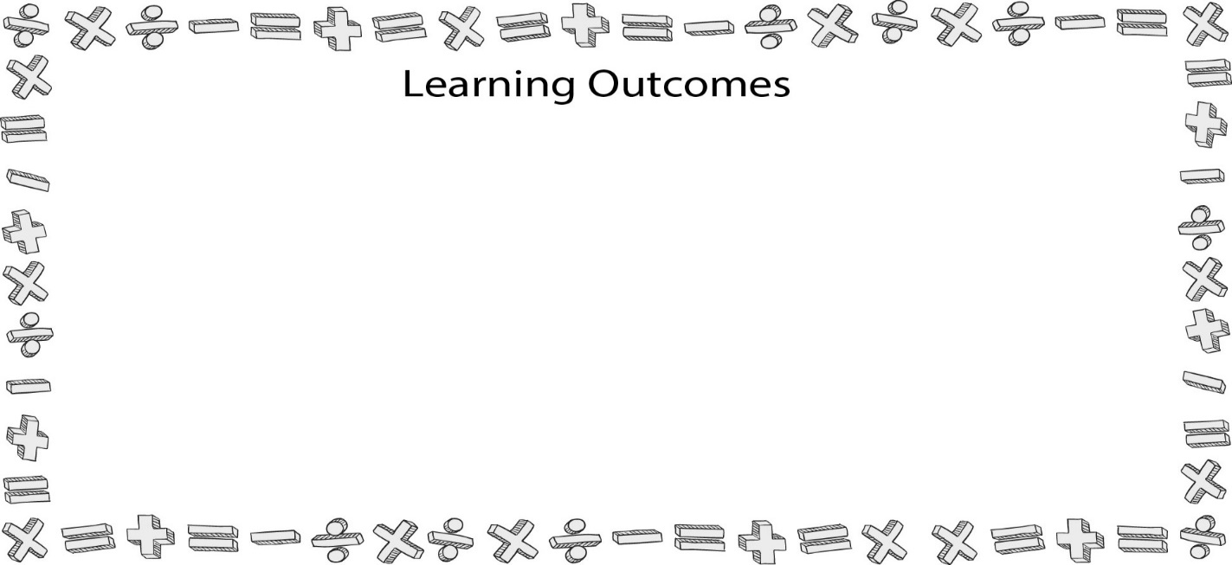
Reliability and Validity
- Define the term reliability.
- Distinguish among the types of reliability discussed in this chapter (test-retest, alternate forms, split-half, and Cronbach’s alpha).
- Calculate a split-half and Cronbach’s alpha reliabilities using Statistical Package for the Social Sciences (SPSS).
- Report reliabilities using correct American Psychological Association (APA) style.
- Define the term validity and differentiate among the three types of criterion validity (predictive, concurrent, and retrospective).

I. Reliability

A. Scalar Reliability

1. Test-retest reliability

2. Alternate forms reliability

3. Split-half reliability

4. Cronbach’s alpha reliability

a. Computer printouts of Cronbach’s alpha

b. SPSS and Cronbach’s alpha

B. APA Discussion

C. Alpha reliabilities from this book

D. Alpha reliabilities in the real world

E. Improving reliability of measurement

1. Item construction

2. Length of instrument

3. Administration of the test

II. Validity

A. Face or content validity

B. Criterion validity

1. Predictive or Prospective validity

2. Concurrent validity

3. Retrospective validity

C. Construct validity

1. Relying on theory

2. Measuring known groups

3. Factorial validity

D. Validity threats

1. Inadequate preoperational explication of concepts

2. Mono-operation bias

3. Interaction of different treatments

4. Interaction of testing and treatment

5. Restricted generalizability across constructs

6. Confounding constructs and levels of constructs

7. Social threats to validity

a. Hypothesis guessing

b. Evaluation apprehension

c. Experimenter expectancies

d. Social desirability bias

III. Problems with Measurement

A. Coefficients

B. Basic Measurement Problems

1. Faking responses

a. Acquiescence

b. Social desirability

c. Screw-you effect

2. Response set

3. Bad measurement items

Chapter Nine
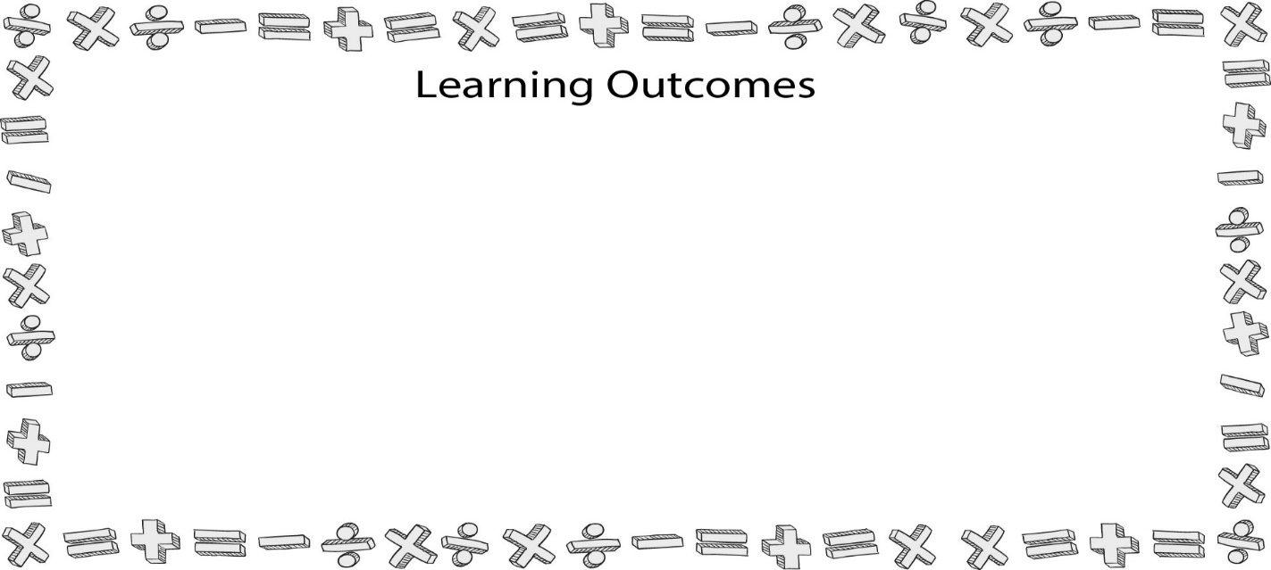
Survey Research
- Distinguish among surveys, questionnaires, and interview schedules.
- Describe Fink’s (2006) five steps for conducting a survey.
- Distinguish among cross-sectional, longitudinal, and accelerated longitudinal survey designs.
- Distinguish between unit and item nonresponses, and discuss how they affect surveys.
- Understand the five different ways a researcher can translate a survey from one language to another.

I. Surveys, Questionnaires, and Interview Schedules

A. Survey

1. Descriptive Survey

2. Analytical or Explanatory Survey

B. Questionnaire

C. Interview Schedule

II. When to Use a Survey

A. Do you know what you want to ask?

B. Do you really need to collect new data?

C. Do your participants know anything, and will they tell you if they do?

D. Does your goal have generalizability?

III. How to Conduct Survey Research

A. Step One: Picking your questions

1. Nominal level questions

2. Ordinal level questions

3. Interval level questions

a. Group items with like anchors together.

b. Do not start with the most controversial questions.

c. Keep like questions together.

d. Keep like contexts together.

e. Place sensitive questions toward the end of the survey.

4. Ratio level questions

5. Open ended questions

B. Step Two: Creating clear instructions

C. Step Three: Study design

1. Cross-sectional survey design

2. Longitudinal survey design

a. Trend survey design

b. Panel survey design

c. Accelerated longitudinal survey design

D. Step Four: Data processing and analysis

E. Step Five: Pilot testing

1. Use actual survey population members

2. Anticipate survey context

3. Test parts of the survey

4. Determining a sample pilot size

5. Ask questions after someone completes the survey

IV. Disseminating Your Surveys

A. Surveying techniques

1. Face-to-face surveying

2. Telephone surveying

B. Self-administration

1. Mass administration

2. Mailed administration

3. Internet administration

4. Advantages and disadvantages of self-administration

V. Problem Areas Associated with Survey Research

A. Response rate

1. Unit nonresponse

2. Item nonresponse

a. Survey mode

b. Interviewer training

c. Question topics

d. Question structure

e. Question difficulty

f. Institutional requirements and policies

g. Respondent attributes

3. Effects of nonresponse

B. Improving response rates

1. Make the survey easy to fill out

2. Keep it short

3. Include a self-addressed stamped envelope (SASE)

4. Include a good cover letter

5. Use multiple administration techniques

VI. Translating Surveys into Other Languages

A. Issues of equivalence

1. Semantic equivalence
2. Conceptual equivalence

3. Normative equivalence

a. Willingness to discuss certain topics

b. Manner in which ideas are expressed

c. Treatment of strangers

B. Methods of Translation

1. Simple direct translation

2. Modified direct translation

3. Translation/backtranslation

4. Parallel blind technique

5. Random probe translation

VII. Using the Research Project Worksheet

Designing a Research Project Worksheet
Developed by Dr. Jason S. Wrench

Question (In a single sentence, what would you like to know when your project is done?)

( ) Survey | ( ) Content analysis | ( ) Data mining | ( ) Randomized  study | ( ) Nonrandom  study
Design (Check one):

If a self-administered survey, How? | ( ) Mass administered | ( ) Mail | ( ) Web based
If a interview based survey, how? | ( ) Phone | ( ) In person
If a content analysis,  what type? | ( ) Mediated | ( ) Interactional | ( ) Microlevel | ( ) Macrolevel
If using pre-existing data? | ( ) Personally  collected | ( ) Governmental  agency | ( ) Other  records | ( ) Other
Type of randomization? | ( ) Non-blind | ( ) Single blind | ( ) Double blind
Type of nonrandomized study? | ( ) Case-Control | ( ) Cohort

Type of Experimental Design:

Quasi Experimental Design
( ) Pretest-Posttest | ( ) Time Series | ( ) Multiple Time Series | ( ) Switching Replications
True Experimental Designs
( ) Pretest-Posttest | ( ) Two Group Posttest Only | ( ) Randomized Switching Replications | ( ) Solomon Four-Group

Setting (Where will the survey/study be conducted?)

Participants

1. Do your participants need to possess any specific characteristics (high levels of communication apprehension, users of instant messaging, relational partner, age grouping, biological sex, etc…)? ( ) YES ( ) NO
If Yes, Explain:
2. How are you going to select/acquire participants?

3. Do you need a letter of consent for participation? (NOTE: All survey and experimental based studies must have a letter of consent.) ( ) YES ( ) NO
If No, Explain why not:

Variables (What are your IVs/DVs, how are they measured, and what level of measurement are they?)

- Independent Variables (label as nominal, ordinal, interval, or ratio):

- Dependent Variables (label as nominal, ordinal, interval, or ratio):

Hypotheses/Research Questions

Statistical Testing (Using the above Hypos/RQs, what statistical tests will you use to answer each question?)

Tentative Study Title:

Principal Researcher(s):

Chapter Ten
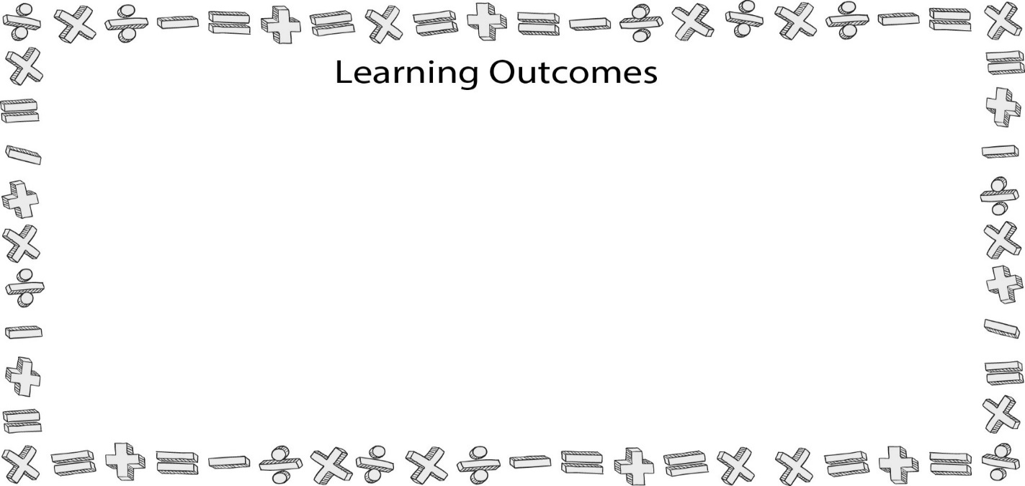
Content Analysis
- Explain the basic principles underlying content analysis.
- Implement the basic steps necessary to conduct a content analysis.
- Define the term coding, and explain how one creates a codebook and coding form.
- Define the term intercoder reliability, and calculate it using Cohen’s kappa.
- Identify four problems that a researcher may encounter with coders (coder misinterpretations, coder in attention, coder fatigue, and recording errors).

I. Content Analysis: A summarizing, quantitative analysis of messages.

II. Conducting a Content Analysis – Nine Steps

A. Theory & Rationale

B. Conceptualization

C. Operationalization

D. Coding Schemes

E. Sampling

F. Training and Pilot Reliability

1. Intro to the codebook and the coding form

2. Sample coding

3. Coding of initial data

4. Initial reliability (AKA: Intercoder reliability)

a. Step One:

b. Step Two:

c. Step Three:

d. APA Write-up

e. Reasons for unsatisfactory (low) Cohen’s kappa

i. The codebook is flawed at conceptual or operational level.

ii. The codebook is confusing, causing coders to miscode data.

iii. One or more of your coders is simply not following the codebook.

5. Retraining

G. Final Coding

1. Coder misinterpretations of data

2. Coder inattention

3. Coder fatigue

4. Recording errors

H. Final reliability

1. For two coders, use Cohen’s kappa

2. For more than two coders, use Krippendorff’s alpha

I. Tabulation and Reporting

Chapter Eleven
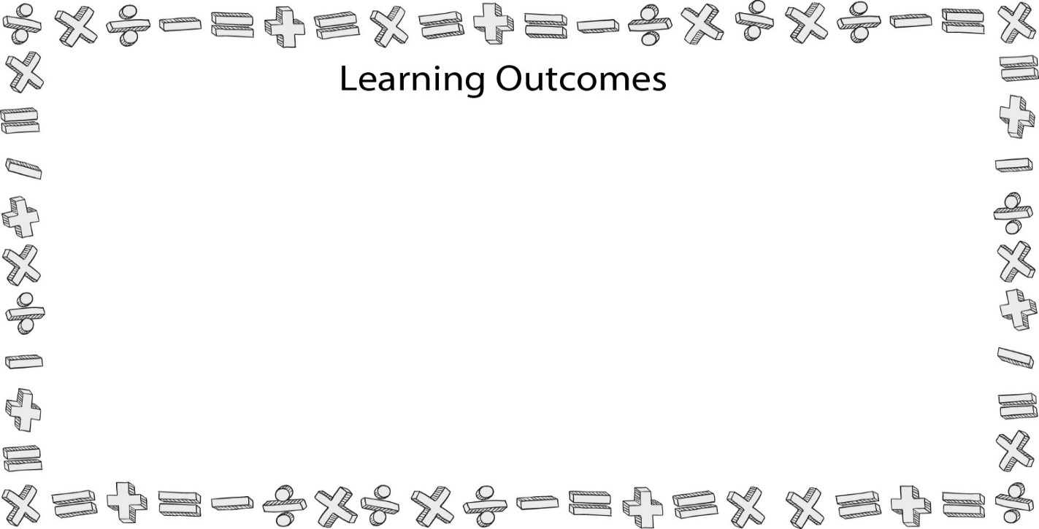
Experimental Design
- Explain the basic parts of an experiment (random assignment, manipulation of the independent variable, measurement of the dependent variable, and control).
- List and explain the four issues researchers must be aware of when attempting to control an experiment (threshold effects, experimenter effects, Hawthorne effect, and intervening variables).
- Differentiate among the three types of confounding variables (suppressor, reinforcer, and lurker).
- Describe six external threats to validity associated with experiments (historical flaw, maturation, testing flaw, regression to the mean, selection threat, and attrition).
- Recognize and explain preexperimental and true experimental designs.

I. What are Experiments and Why Do We Do Them?

A. Experiment: When a researcher purposefully manipulates one or more variables (independent variables) in the hop of see how this manipulation effects change or lack of change of other variables of interest (dependent variables).

B. Rationale for experimental research

1. Determining causal relationships

2. Ruling out alternative explanations

3. Determining the influence of intervening and antecedent variables

a. Antecedent variable

b. Intervening variable

4. Determining cause or chance

II. Aspects of Experimental Design

A. Random assignment

B. Manipulation of the independent variable

1. Ways to manipulate an independent variable

a. Providing a stimulus

b. Manipulating written materials

c. Manipulating audio or video recordings

d. Computer simulations

e. Use of research confederates

f. Hypothetical scenarios and role-playing activities

2. Factorial experimental designs

C. Measurement of the dependent variable

1. Ways to measure dependent variables

a. Mental measures

b. Observe behaviors

2. Control of the experiment

a. Researchers must not affect the experiment

b. Issues with experimentation

i. Threshold effects

ii. Experimenter effects

iii. Hawthorne effect

iv. Extraneous variables

a. Intervening variables

b. Confounding variables

i. Suppressor variable

ii. Reinforcer variable

iii. Lurker variable

III. Conducting an Experiment

A. Introduce the experiment and obtain consent

1. Honesty vs. deception

2. Obtaining content

B. Randomly assign participants to different conditions

C. Manipulate the independent variable (IV)

1. Manipulate the variable

2. Perform a manipulation check

a. Manipulation check: Procedure where a researcher inserts a quantitative measurement into a study to determine whether different conditions portray the independent variable differently.

b. Why do we use manipulation checks?

c. Example of a manipulation check

D. Measure the dependent variable (DV)

E. Debrief the participants when the experiment is completed

1. Debriefing: Period following an experiment when a researcher corrects any deception, reaffirms the value of the experiment, and determines if the participant has altered her or his answers based on what she or he assumed was occurring.

2. Stages of debriefing

a. Correct deception

b. Reaffirm the value of the research

c. Reaffirm the value of participation

d. Ask questions

i. Check for lying / response bias

ii. Check for anxiety

IV. Threats to Experimental Validity

A. Historical flaw

B. Maturation

C. Testing flaw

D. Regression to the mean

E. Selection threat

F. Attrition

V. Replication

A. Why we replicate research

1. Determine if original results are were by error or remain constant.

2. Examine a variable using new population characteristics.

3. Examine a new context for previous research.

4. Combine results from two or more studies.

B. Four types of replication

1. Literal replication

2. Operational replication

3. Instrumental replication

4. Constructive replication

VI. Common Experimental Designs

O = Observation (1, 2, 3 . . . X)

X = Treatment or manipulation

IV = Independent Variable

R = Randomized

N = Nonrandomized

C = Groups are created by a cutoff score

A. Preexperimental designs

1. One-shot case study

N X₁ O

2. One –group pretest-post-test

N O₁ X O₂

3. Static group comparisons

N X₁ O

N X₀ O

B. Quasi-experimental designs

1. Pretest-posttest

N O₁ X O₂

N O₁ O₂

2. Time series

N O₁ O₂ O₃ X₁ O₄ O₅ O₆

3. Multiple time series

N O₁ O₂ O₃ X₁ O₄ O₅ O₆

N O₁ O₂ O₃ X₀ O₄ O₅ O₆

4. Switching replications

N O₁ X₁ O₂ O₃

N O₁ O₂ X₁ O₃

C. True experimental designs

1. Pretest-posttest

R O₁ X₁ O₂

R O₁ O₂

2. Two-group posttest only

R X₁ O₁

R O₁

3. Randomized switching replications

R O₁ X₁ O₂ O₃

R O₁ O₂ X₁ O₃

4. Solomon four-group

R O₁ X₁ O₂

R O₁ O₂

R X₁

R O₂

VII. Ex Post Facto Design

VIII. Final Thoughts on Experiments

A. Problems with experiments

1. Limited number of variables

2. Generalizability problems

a. Overreliance on college student samples

b. Overreliance on laboratory settings

c. Low in mundane realism

3. Enhancing generalizability

a. Use field experiments

b. Use more complex studies examining multiple IVs

Chapter Twelve
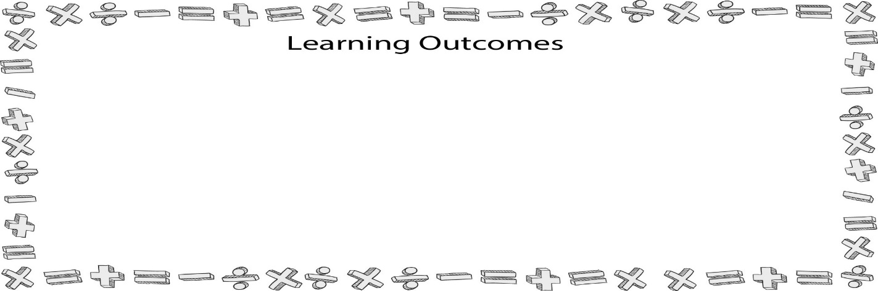
Sampling Methods
- Distinguish between the terms sampling and populations.
- Explain the central limits theorem.
- Differentiate among the different probability and nonprobability samples.
- Explain the general rules for determining a necessary sample size.
- Describe the relationship between confidence intervals and sample sizes.

I. Why Use a Sample?

A. Sampling

B. Population

C. Sample

II. The Sampling Process

A. Identify the theoretical population

B. Identify the potential participants

C. Select the sample

III. Selecting a Sample Design

A Probability sampling

1. Defined

a. Involves randomly selecting participants.

b. Allows for the calculation of sampling error

c. Central limits theorem

2. Types of probability samples

a. Simple random samples

b. Stratified random samples

c. Cluster samples

d. Systematic samples

B. Sampling error

C. Nonprobability sampling

1. Defined

a. Involves the nonrandom selection of participants.

b. Greater chance for bias to exist in the results.

c. Does not allow for the calculation of sampling error.

2. Why researchers use nonprobability samples

a. Examine a new variable or phenomenon

b. Difficult to find participants with specific characteristics

c. Sensitive subject matter of study

d. More efficient or cost-productive

3. Types of nonprobability samples

a. Convenience samples

b. Volunteer samples

c. Purposive samples

d. Quota samples (proportionate vs. nonproportionate)

e. Network samples

IV. Determining Sample Size

A. Determine your confidence interval

V. Common Sense Sample Recruiting

A. Know your target population

B. Approaches to recruitment

1. Face-to-face

2. Advertisement

3. Letters

4. Email

5. Snowball

6. Purchasing samples

C. Ethical recruitment

1. IRB approval

2. Refrain from pressuring people

3. Be honest

Chapter Thirteen
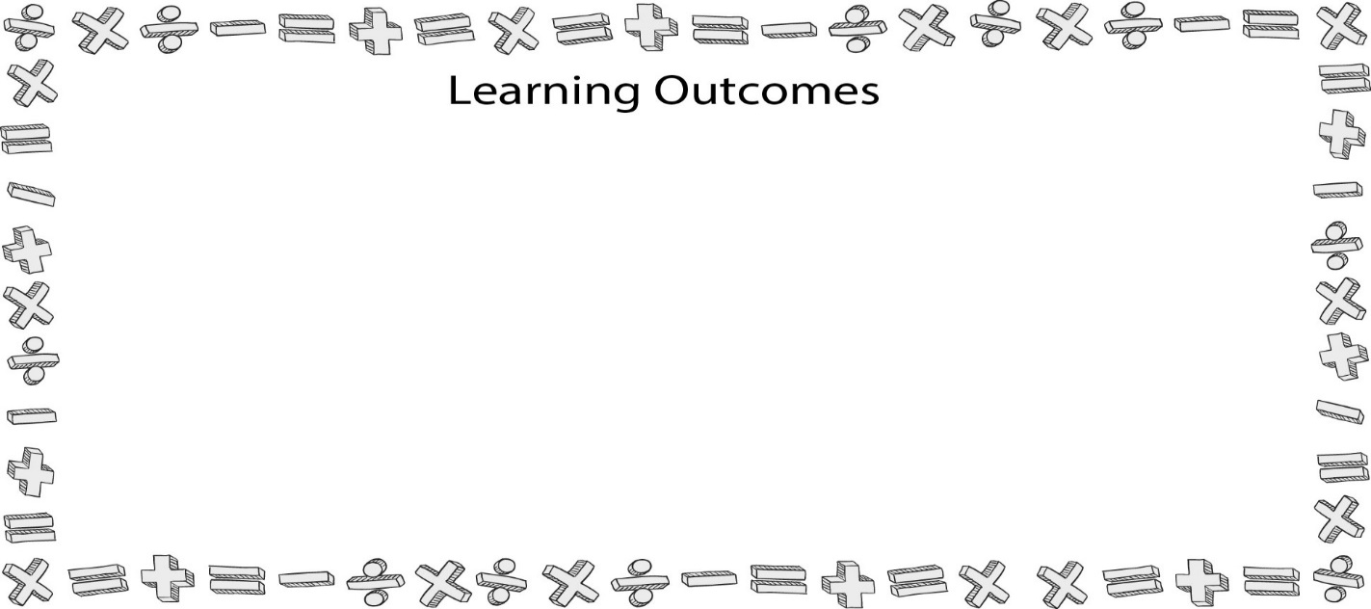
Hypothesis Testing
- Create both one-tailed and two-tailed hypotheses and directional and nondirectional research questions, and explain when they are appropriate to use in research
- Describe the mathematical nature of sampling error
- Explain the importance of a 95% confidence interval in scientific research
- Describe the process a researcher goes through for significance testing
- Describe both type I (α) and type II (β) errors.

I. Defining the Terms

A. Hypothesis

B. What makes a good hypothesis?

C. Types of hypotheses

1. One-tailed

2. Two-tailed

D. Research questions

1. Directional

2. Nondirectional

E. Alternative Hypothesis

1. Defined

2. Example - H₁

F. Null Hypothesis

1. Defined

2. Example - H₀.

G. Hypothesis testing

II. Hypothesis Testing Case Study

III. From Random Samples to a Whole Population

A. Sampling error

B. 95% confidence interval

C. Confidence levels across research fields

IV. Testing for Significance

A. Significance testing

B. Steps

1. Step 1: Set the probability level

2. Step 2: Conduct a statistical test

3. Step 3: Compare calculated and critical values

V. Testing for Power

A. Power

B. One-tailed vs. two-tailed hypotheses

VI. Effect Sizes

A. Defined

B. Large vs. small effects

VII. Understanding Error

A. The confidence interval

1. 1 – α

2. H0 is true, and you accept H0

3. How many times out of 100 that your results will say there is no effect (difference or relationship) and there really is no effect.

4. Significant vs. nonsignificant p values (see Figure 13.6 in text)

B. Power - odds of saying there is a difference or relationship when in fact there is one.

1. 1 – β

2. H0 is false, and you reject H0

3. Number of times out of 100 when there is an effect; we’ll say there is one.

C. Type I Error

1. α error

2. H0 is true, but you reject H0

3. Number of times out of 100 when there is no effect; we’ll say there is one.

D. Type II Error

1. β error

2. H0 is false, but you accept H0

3. Number of times out of 100 when there is an effect; we’ll say there is none.

Chapter Fourteen
Descriptive Statistics
- Define the term statistic, and discriminate between descriptive and inferential statistics.
- Explain and calculate the measures of central tendency discussed in the chapter (mean, median, and mode).
- Explain the purpose of skewness and kurtosis.
- Calculate and explain the measures of variability discussed in the chapter (range, sum of squares, variance, and standard deviation).
- Evaluate the measures of central tendency and measures of variability for the variables collected in the textbook’s dataset.

I. What is a Statistic?

A. Statistic

B. Benefits of statistics

1. Describe

2. Organize

3. Interpret

C. Descriptive vs. inferential statistics

1. Data

2. Descriptive statistics

a. Statistics used to organize and summarize information or data.

b. Most commonly used descriptive statistic are percentages.

3. Inferential statistics

a. Population

b. Sample

II. Measures of Central Tendency (see text for instructions for calculating)

A. Mean

1. Defined

2. Calculating a mean

a. All the numbers of a sample together.

b. Take the summed total (Σx) and divide it by the number of scores in the group (n).

B. Median

1. Defined

2. Calculating a median

a. Odd number of scores/items.

b. Even number of scores/items.

3. Best to use when reporting on the average for data with extreme scores.

C. Mode

1. Defined

2. Calculating a mode
.

D. Frequency Distributions

1. Calculating a frequency distribution using SPSS (See Figures 15.4-15.11 in text for steps and examples of SPSS output).

2. Histogram (See Figure 14.10 in text for sample).

3. Outliers

4. Bell curve / normal distribution

a. If the scores are distributed normally, the curve forms a bell shape.

b. Normality of data is a condition for certain statistical analyses associated with hypothesis testing.

E. Skewness & Kurtosis

1. Skewness

a. More often than not, the dataset you are analyzing will produce a curve that is asymmetrical.

b. The asymmetry in a set of data points is referred to as the dataset’s skewness.

c. Positively skewed curve

i. Tail of the distribution curve is longer on the right side.

ii. The majority of scores are low, creating a long tail in the positive direction on a number line.

iii. The mean of the sample will be larger than the mode or median

iv. See Figure 15.12 in text for example.

d. Negatively skewed curve

i. Tail of the distribution curve is longer on the left side.

ii. The majority of the scores are high, creating a long tail in the negative direction on a number line.

iii. The mean will be smaller than the mode or median.

iv. See Figure 15.13 in text for example

2. Kurtosis

a. The degree of peakedness of a distribution of scores.

b. In distributions, the kurtosis can either be very peaked with short, thick tails or too flat with long, thin tails.

c. If the kurtosis value is above 0, then the distribution is peaked with short, thick tails.

d. If the kurtosis value is below 0, then the distribution is flat and has too many cases in the tails.

e. See Figure 14.14 in text for example of SPSS frequency with skewness and kurtosis scores.

III. Measures of Variability

A. Range

1. Defined

2. Formula - Range = X_{max} – X_{min}

3. Calculating a range

4. Tells us the gap between the high and low score, but it does not summarize how each score in the distribution differs from the mean.

B. Sum of Squares
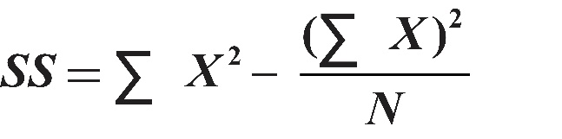
1. Defined

2. Calculating a Sum of Squares – (See Figure 15.15 in text)

SS = sum of squares

Σ = sum of all the numbers added together

X² = sum of all the squared numbers in a series

(ΣX)² = sum of all the numbers added up first and then squared

N = number in population

C. Variance

1. Defined

2. Calculating a variance

D. Standard Deviation
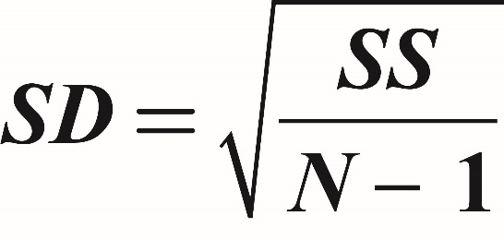
1. Defined

2. Calculating a standard deviation - taking the square root of the variance.

E. SPSS and Measures of Variability (See Figures 15.19a – 15.19f in text)

Chapter Fifteen
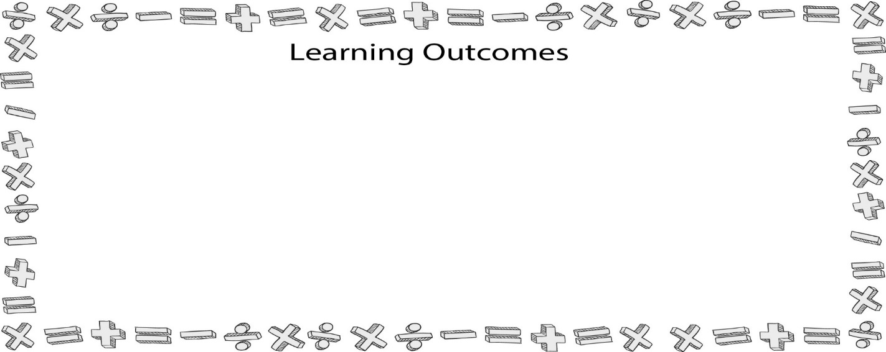
Chi-Square (χ2) Test of Independence
- Explain the purposes of a chi-square (χ2) statistical test.
- Calculate a chi-square test by hand.
- Conduct a chi-square test using Statistical Package for the Social Sciences (SPSS).
- Analyze the use of the chi-square test in the article by Brummans and Miller (2004).
- Explain the purpose of phi (Φ), how one calculates phi by hand, and how to interpret phi in research.

I. What is a Chi-Square?

A. Definitions

B. Assumptions

C. Chi-Square and statistical significance

D. Chi-Square formula

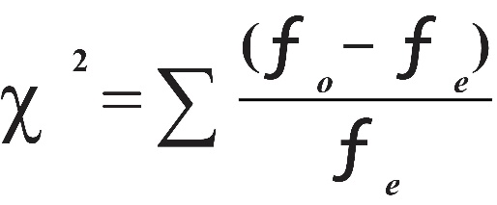

II. Step-by-Step Approach to the Chi-Square Test of Independence

A. Step One: Add the totals from each row and column separately.

B. Step Two: Calculate the expected frequency = (total column × total row)/overall total.

C. Step Three: Calculate the χ² = sum of ((observed frequencies − expected frequencies)²/expected frequencies).

D. Step Four: Since the sigma was in front of the formula, now we just add all of the values we just created together.

E. Step Five: Calculate degrees of freedom for the chi-square computed.

F. Step Six: Identify the critical value to determine if the chi-square calculated value is statistically significant.

III. Computer Printouts of the Chi-Square Test of Independence

A. SPSS and Chi-Square (See Figures 15.7 – 15.10 in text)

B. Cramer’s phi (Φ)
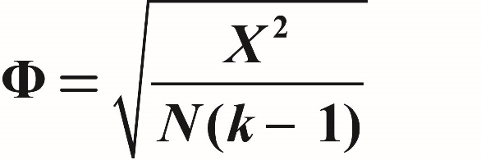

C. APA Write-Up

D. Discussion of findings

E. Post Hoc APA Write-Up

IV. Biological Sex and Book Edition

A. Biological sex (female vs. male) and book edition (1st vs. 2nd)

B. See Figure 15.14 in text

C. APA Write-up

V. Discussion of Brummans and Miller’s Article (2004)

A. Article’s purpose

B. Methodology

C. Results

Chapter Sixteen
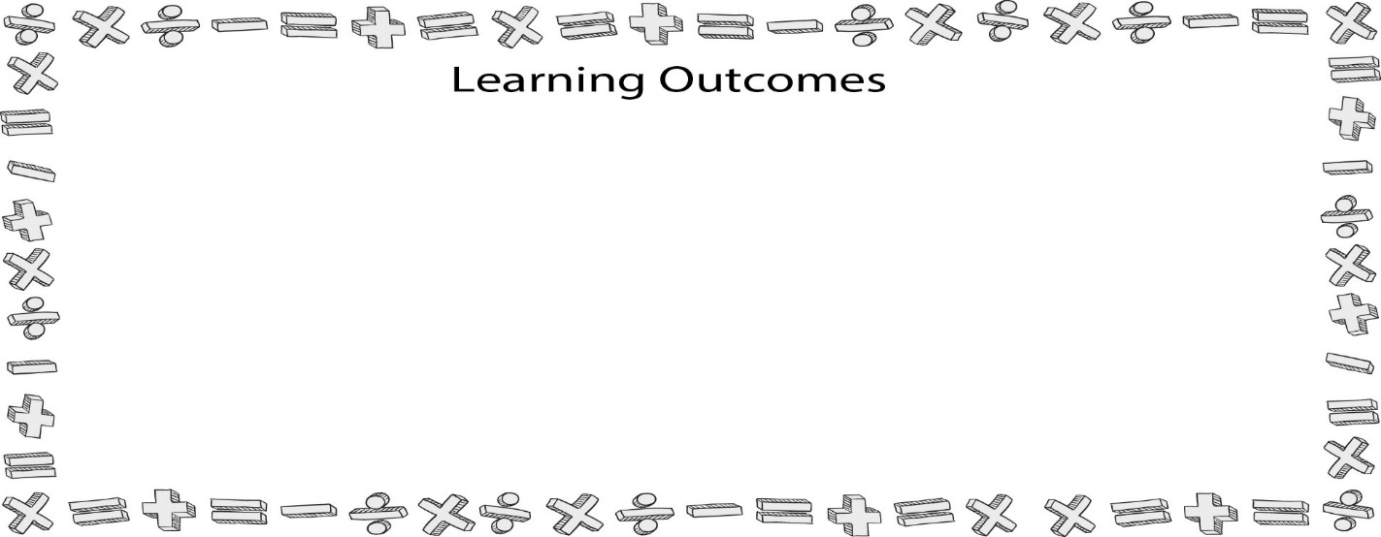
Independent Samples t-Tests
- Explain the purposes of a t-test.
- Calculate a t-test by hand.
- Conduct a t-test using Statistical Package for the Social Sciences (SPSS).
- Analyze the use of the t-test in the article by Weber, Fornash, Corrigan, and Neupauer (2003).
- Explain the purpose of Cohen’s d (statistic for the effect size of a t-test), how one calculates Cohen’s d by hand, and how to interpret Cohen’s d.

I. What is an Independent Samples t-Test?

A. Background information

1. Compare two nominal independent variables on one dependent variable.

2. Group independence

B. Assumptions

C. Formula
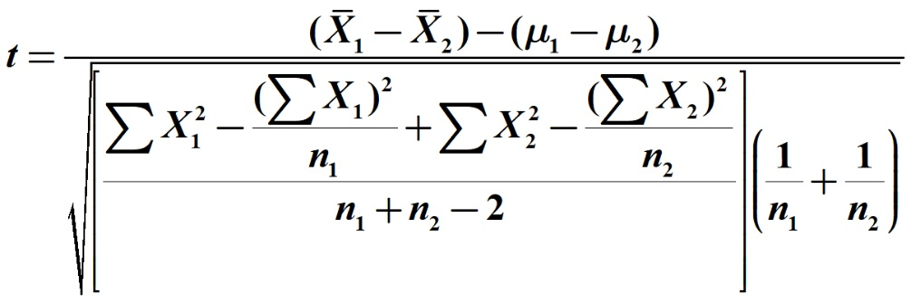

II. Step-by-Step Approach to the Independent Samples t-Test

(Please read the corresponding chapter for the detailed explanation of the mathematical computation of an independent samples t-Test.)

III. Computer Printouts of the Independent Samples t-Test

A. Step One

1. Find the ΣX₁ (Group One), the mean (Group One) and the sum of squares ΣX₁² (Group One).

2. Repeat the process for Group Two scores.

B. Step Two

1. Start with this formula for Group One is (ΣX₁)²/n₁.

2. Repeat with the same formula for Group Two (ΣX₂)²/n₂.

C. Step Three

1. Subtract the sum of squares for Group One from the portion of the formula that was computed for Group One in Step Two.

2. Repeat this for Group Two (subtract the sum of squares for Group Two from the portion of the formula that was computed for Group Two in Step Two.

D. Step Four

1. Add both numbers calculated in Step 3 together.

2. Complete the following formula (n₁ + n₂ – 2)

3. Divide the first number calculated in this step by the second number calculated in this step.

E. Step Five - calculate

F. Step Six

1. Take the number calculated in the third part of Step Four and multiply it by the number calculated in Step Five.

2. Take this number and find its square root.

G. Step Seven - calculate the top portion of the formula .

H. Step Eight – Divide the value calculated in Step Seven by the value calculated in Step Six.

I. Step Nine – calculate the degrees of freedom using (df = n₁ + n₂ – 2).

J. Step Ten – Review the t test critical value table (See Figure 16.7 in text) using the degrees of freedom (calculated in Step Nine).

IV. SPSS and the Independent Samples t-Test (See Figure 17.8 in text for a sample printout)

A. Calculating a t-Test in SPSS

1. Open your SPSS software, and then locate the file on the textbook’s website in the SPSS folder called “t test.”

2. When you open this file, you will see two variables listed, “class” and “score.”

3. Go to the menu bar at the top of your screen and click “Analyze.”

4. Go to the “Compare Means” category on this menu, scroll over the arrow, and another menu will appear to the right.

5. From the “Compare Means” menu, click on “Independent Samples T Test” (See Figure 17.9 in text).

6. On this screen, you will see three major boxes. On the left side is a box with your variables already listed. On the upper right is a box labeled “Test Variable(s),” and below that is a small box labeled “Grouping Variable.”

7. Select and place the dependent variables that you are attempting to analyze in the “Test Variable(s)” box.

8. Select and place the independent variable class to the “Grouping Variable” box.

9. In the Grouping Variable box, click the button labeled “Define Groups.”

10. Tell your computer what numbers you chose to represent those two levels of our independent variable (EX: 1 and 2).

11. Click the “Continue” button and then click “OK.”

12. Results from the SPSS analysis will appear (See Figure 17.11 for a sample).

B. APA write-up – example

C. Discussion of findings

V. Calculating Effect Sizes

A. Effect sizes revisited

1. The size of the difference between the two groups.

2. The relationship may be statistically significant, but how big a difference are we really talking about?

B. Effect size formula
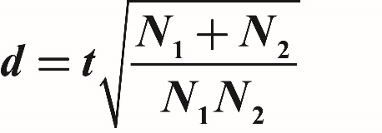

C. Interpreting Cohen’s d

0.2 – small effect size

0.5 – medium effect size

0.8 – large effect size

VI. Discussion of the Weber, Fornash, Corrigan & Neupauer (2003) Article

A. Article purpose

B. Methodology

C. Results

VII. Paired t Tests

A. Used to compare two interval/ratio level scores that are taken from the same group at two distinct time periods.

B. Most commonly used in conjunction with experiments.

Chapter Seventeen

One-Way Analysis of Variance (ANOVA)
- Explain the purposes of a one-way analysis of variance (ANOVA).
- Calculate a one-way ANOVA by hand.
- Conduct a one-way ANOVA using Statistical Package for the Social Sciences (SPSS).
- Analyze the use of the one-way ANOVA in the article by Boiarsky, Long, and Thayer (1999).

I. What is a One-Way ANOVA?

A. Defined

1. Compares two or more nominal independent variables on one dependent variable.

2. Group independence

3. General linear model

B. Assumptions

1. The dependent variable must be an interval or ratio variable.

2. The independent variable must be a nominal variable.

3. The dependent variable should be normally distributed.

4. A sample should be drawn from populations with equal variances on the dependent variable.

5. The participants contributing data should represent a random sample drawn from the population of interest.

C. Formulas
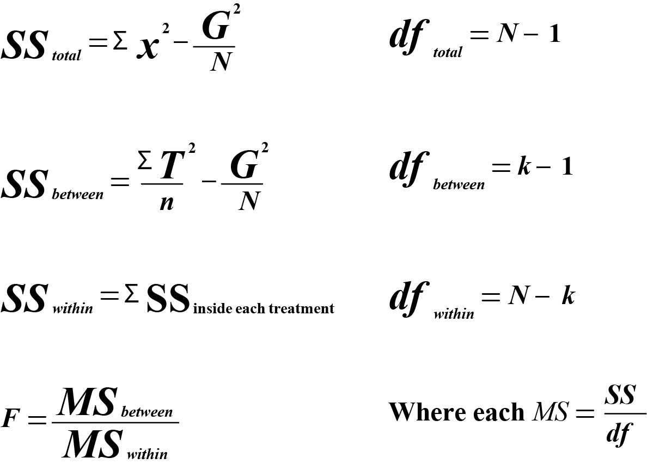

II. Step-by-Step Approach to One-Way ANOVA

(Please read the corresponding chapter for the detailed explanation of the mathematical computation of a one-way ANOVA.)

A. Step One

1. Determine the X for each of the three groups

2. (See Figure 17.3 in text)

B. Step Two

1. Calculate the part of the formula represented in Figure 18.4.

2. (ΣT²/n) – take the T values, square them, then divide them by the number of participants in each column.

C. Step Three

1. Calculate the second part of the SS_{between} formula.

2. G²/N

3. Calculate G by taking the T values in Step One and add then together for a summed total.

4. Square the G, then divide that result by the total number of participants in the study N.

D. Step Four

1. Final step in calculating the SS_{between}.

2. Take the value of Step Two and subtract it from the value in Step Three

3. (ΣT²/n) – (G²/N).

E Step Five

1. Calculate the sum of squares within (SS_{within}) formula represented in Figure 178.

2. First, find the mean for each group.

3. Take the T value computed for each group in Figure 18.3 and then divide the T value by the number of participants in that group.

4. Repeat these steps for the other groups.

5. Once you have the averages computed, subtract the individual scores for each participant in a group from the group average and then square that number.

6. Take the three scores, and add then together (See Figure 18.6 in text).

F. Step Six

1. Calculate the SS_{total}.

2. Add SS_{between} from Step Four and SS_{within} from Step Five together

G. Step Seven.

1. Calculate the degrees of freedom between (df_{between}) and degrees of freedom within (df_{within}).

2. To compute df_{between}, the formula is K-1, or the number of groups minus 1.

3. To computer df_{within}, the formula is N – K, or the total number of participants in the study minus the number of groups.

H. Step Eight

1. Calculate the two mean squares (MS) for between (MS_{between})and within (MS_{within}).

2. For the MSb_{etween}, divide SS_{between} calculated in Step Four by the df calculated in Step Seven.

3. For the MS_{within}, divide SS_{within} calculated in Step Five by the df calculated in Step Seven.

I. Step Nine

1. Calculate the F ratio.

2. Divide MS_{between} by MS_{within}.

J. Step Ten

1. Locate the critical value for the F distribution (See Figure 18.7 in text).

2. Look for the df_{between} (top/columns) and the df_{within} (left-hand side/rows).

K. Step Eleven

1. Create an ANOVA summary table.

2. See Figure 18.8 in text for an example.

III. SPSS and One-Way ANOVAs (See Figures 18.9 – 18.11 in text)

A. Steps to calculate

1. Go to the menu bar at the top of your screen, and click on “Analyze.”

2. Go to the category “General Linear Model” from the drop-down menu, scroll over the arrow, and another menu will appear to the right.

3. The first option on the General Linear Model menu is “Univariate” – select this and you will see six boxes.

4. The first box, on the left side of the Univariate dialogue box, will contain your variables.

5. To the right, on top, is the “Dependent Variable” box. To place the your DV in this box, click and highlight the variable time and click the right arrow button next to the Dependent Variable box.

6. Below that box is the “Fixed Factor(s)” box, which is where you place your nominal independent variable. Click the IV then click the right arrow button next to the “Fixed Factor(s)” box.

7. To the right of those boxes, you will see the buttons “Model,” “Contrasts,” “Plots,” “Post Hoc,” “Save,” and “Options.” Click on Post Hoc.

8 “Univariate: Post Hoc Multiple Comparisons for Observed Means” dialogue box will appear. Choose the Factor(s) you want to compute a post hoc analysis for by selecting the variable and clicking the arrow between the “Factor(s)” box and the “Post Hoc Tests for” box.

9. After you have sent your Factor variable over to the Post Hoc Tests for box, you will note that the various post hoc tests are now active. One grouping is for “Equal Variances Assumed,” and one is for “Equal Variances Not Assumed.” Check the box next to the “Tukey” post hoc test under the “Equal Variances Assumed” list.

10. Click “Continue.”

11. Press the button at the right side of the dialogue box marked “Options.” You will find two boxes on top and a variety of options at the bottom.

12. Select the variable you want options for on the left in the “Factor(s) and Factor Interactions” box and then send the variable over to the “Display Means for” box on the right.

13. Select “Descriptive Statistics” and “Estimates of effect size” and click “Continue” then “OK.”

14. See sample results for SPSS in Figure 18.12 in text.

B. Interpreting Eta-square (η²)

η² ≤ 0.04 — statistically significant, but weak/small

0.04 < η² ≤ .36 — medium or moderate effect size

η² > 0.36 — large or strong effect size

C. Multiple Comparison Tests

1. Fisher’s least significant difference (LSD)

2. Student Newman-Keuls (SNK)

3. Tukey’s honestly significance difference test (HSD)

4. Scheffé (Scheffé)

D. APA write-up without a chart

E. APA write-up with a chart

F. Discussion of findings

IV. Discussion of Boiarsky, Long, and Thayer Article (1999)

A. Article purpose

B. Methodology

C. Results

Chapter Eighteen
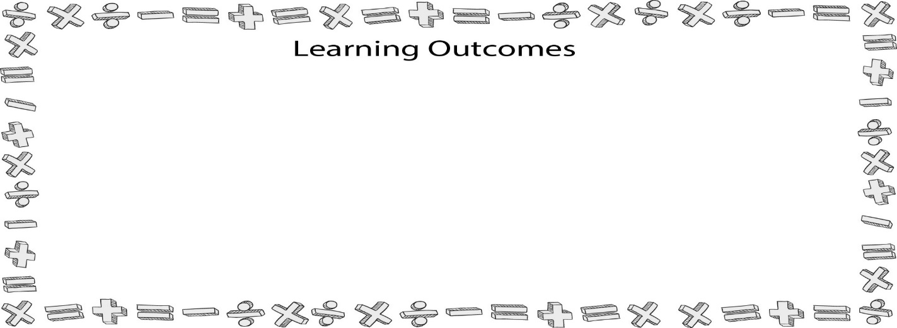
Correlation
- Describe the different types of relationships (positive, negative, curvilinear, and neutral).
- Calculate a correlation by hand.
- Conduct a correlation using Statistical Package for the Social Sciences (SPSS).
- Interpret large correlation tables.
- Analyze the use of the correlations in the articles by Chesebro (1999) and Punyanunt (2000).

I. Correlation (r)

A. What is a Correlation?

1. Pearson product-moment correlation (r) measures the degree to which two quantitative variables (Likert/ratio) are linearly related in a sample.

2. Looks at how changes in one variable correspond to changes in another variable (EX: relationships).

a. Positive relationship

b. Negative relationship

c. Curvilinear relationship

d. Neutral or nonneutral relationship

3. Correlation ≠ causation

B. Assumptions

1. Both the independent variable and the dependent variable should be interval.

2. A sample should be random.

3. Scores for both variables being compared must be obtained from each participant.

4. The relationship between the two scores should be linear (positive or negative) because the Pearson product-moment correlation (the test we will be conducting) does not test for curvilinear relationships.

5. To avoid having an abnormal distribution, the Pearson product-moment correlation should have no fewer than 25 participants.

C. Formula (see Figure 18.2 in text)

1. What does r represent?

r = | degree to which X and Y vary together
r = | degree to which X and Y vary separately

r = | covariance of X and Y
r = | variance of X and Y

2. Formula
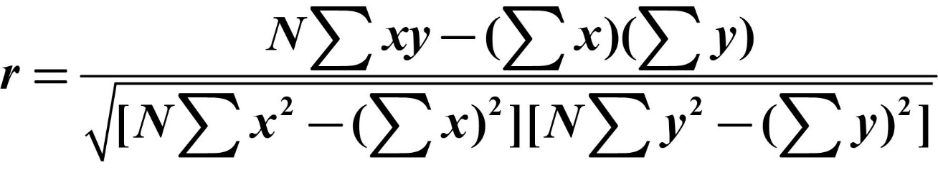

II. Step-by-Step Approach to the Pearson Product-Moment Correlation

(Please read the corresponding chapter for a detailed explanation of the mathematical computation of a correlation.)

A. Steps involved in calculating a correlation.

1. Step One

a. Calculate the sum of x multiplied by y (Σxy).

b. Determine the sum of squares x (Σx²) and then the sum of squares y (Σy²).

c. To calculate r, you need to know the sum of x, the sum of x-square, the sum of y, the sum of y-square, and the number of participants (N).

2. Step Two

a. Calculate the part of the equation that appears above the division line in the formula -NΣxy – (Σx)(Σy).

b. Plug in the numbers obtained in Step One.

3. Step Three

a. Compute the part of the equation that appears below the division line in the formula – left bracket [N∑x² – (∑x)²].

b. Simply plug in results from Step One.

4. Step Four

a. Compute the part of the equation that appears below the division line in the formula – right bracket [NΣy² – (Σy)²].

b. Again, simply plug in the numbers obtained in Step One.

5. Step Five

a. Multiple the answer from Step Three by the answer from Step Four.

b. Then, take the square root of that number.

6. Step Six - divide the number from the top (Step Two) by the number from the bottom of the equation (Step Five).

7. Step Seven

a. Determine if the r is statistically significant.

b. Calculate the degrees of freedom (df) = N – 2.

c. See Figure 19.5 in text for critical values table for the Pearson Product-Moment correlation.

B. Interpreting a correlation

1. Less than .30 (or –.30), then it is a weak relationship (and somewhat questionable)

2. Between .30 and .59 (or –.30 to –.59), then it is a moderate relationship (there is a clear relationship, but it’s not strong)

3. Above .60 (or –.60), it is a strong relationship (there is a clear, strong relationship between the two variables)

III. SPSS and the Pearson Product-Moment Correlation (see Figures 19.6-19.9 in text)

A. Steps for SPSS computation of correlation.

1. Click on “Analyze” in menu bar at the top of screen in SPSS.

2. From the drop-down menu, go to “Correlate,” scroll over the arrow, and another menu will appear to the right.

3. Scroll over “Bivariate,” and click- the “Bivariate Correlations” dialogue box now appears.

4. Highlight both variables you wish to examine, and move them to the “Variables” box.

5. Click on “OK.”

6. Results for the SPSS results can be seen in Figure 19.9 in text.

B. APA write-up

IV. Reading Large Correlation Tables (See figure 18.10)

V. Discussion of the Chesebro (1999) article

A. Article purpose

B. Methodology

C. Results

VI. Discussion of the Punyanunt (2000) article

A. Article purpose

B. Methodology

C. Results

Chapter Nineteen
Regression
- Explain the purposes of a linear regression.
- Calculate a linear regression by hand.
- Conduct a linear regression using the Statistical Package for the Social Sciences (SPSS).
- Explain the purposes of a multiple linear regression.
- Analyze the use of regressions in the articles by Wrench and Booth-Butterfield (2003) and Rocca and Vogl-Bauer (1999).

I. What Is a Regression?

A. Regression Background

1. Graphing a line: Y = mX + b

2. General linear model

B. Assumptions

1. Both the independent variable (IV) and the dependent variable (DV) should be interval.

2. A sample should be random.

3. Scores for both variables being compared must be obtained from each participant.

4. The cases represent scores that are independent of each other from one participant in your sample to the next participant.

5. The DV must be normally distributed in the population for each level of the IV.

6. The population variances of the DV are the same for all levels of the IV.

C. Formula

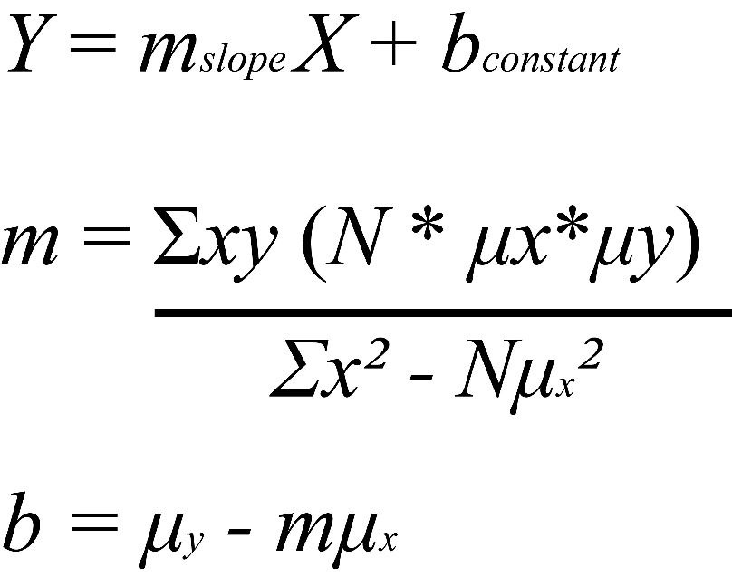

II. Step-by-Step Approach to the Linear Regression

A. R

1. What is R?

2. What is R²?

B. Step-by-Step Calculations

1. Step One – Find the mean of x (µx) and the mean of y (µy).

2. Step Two - compute the top portion of the formula for Σxy – (n × Σµx × Σµy).

3. Step Three – calculate the portion located below the division bar Σx² – Nµx².

4. Step Four – divided the findings from Step Two by the findings from Step Three.

5. Step Five – find the constant (b) by filling in the following equation: b = µy – bµ.

6. Step Six - complete the linear equation of Y = mX + b.

III. SPSS and Simple Linear Regressions

A. Steps to calculate an SPSS Linear Regression.

1. In menu bar at the top of your screen, click on “Analyze” and a drop-down menu will appear.

2. Go to the ninth category on this menu, “Regression,” and then scroll over the arrow - a menu will appear to the right.

3. Scroll over the second option in this list, “Linear,” and click. A dialogue box will then appear.

4. Place the IV in the second box down labeled “Independent(s).”

5. Next, place the DV in the “Dependent” box.

6. Click “OK.”

7. The first column of results reports the R value for this linear regression. Since this is bivariate (only two variables) the R value is the same computational value received for r in the last chapter.

8. The second box is the R-squared (R²) value - R² determines what proportion of the variability in Y or your DV can be predicted by its relationship with X or your IV.

IV. Understanding Multiple Linear Regression

A. Background

1. Multiple IVs accounting for variance in one DV

2. Pictorial explanation (See Figure 19.9)

B. Beta (β) weights

C. APA write-up

V. Discussion of Wrench & Booth-Butterfield (2003) article

A. Article purpose

B. Methodology

C. Results

VI. Discussion of Rocca & Vogl-Bauer (1999) article

A. Article purpose

B. Methodology

C. Results

Chapter Twenty
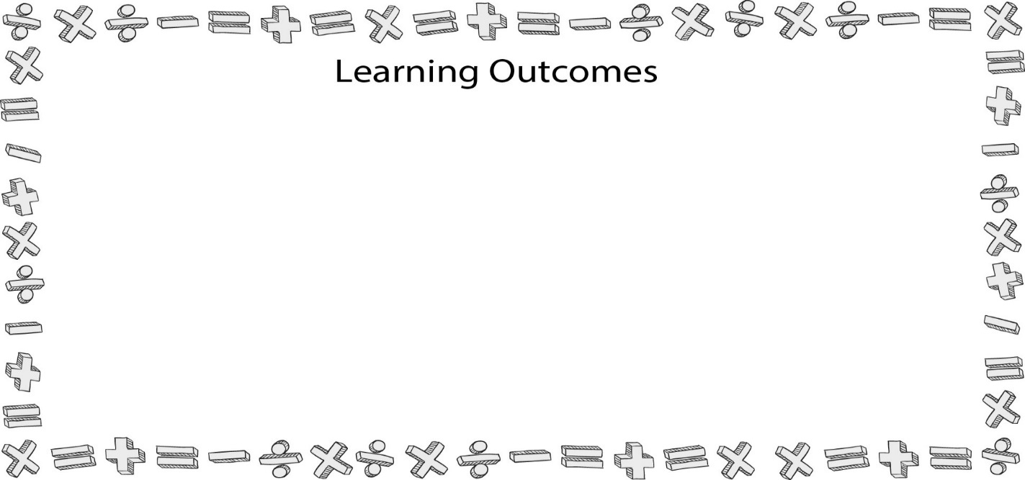
Presenting Research
- Write discussion sections and abstracts.
- Differentiate among the three types of conference presentations (paper, poster, and panel).
- Explain the process one goes through for submitting a paper to a conference.
- Describe process one goes through for submitting a paper to an academic journal.
- Explain the three responses an author may receive from a journal editor (accept for publication, publish pending revisions, revise and resubmit, and reject).

I. Writing a Discussion Section

A. Writing a Results Section

1. The five previous chapters help you write results.

2. Each chapter contained APA write-ups.

3. Do not discuss the results in the results section.

B. Five Goals for a Discussion Section

1. Summarize major findings and results.

2. Interpret findings.

3. Discuss the relationship between the findings and previous research.

4. Acknowledge any limitations of the study.

a. Design

b. Population/sample

c. Methods

d. Instrumentation

5. Discuss implications of findings & suggest future research directions.

II. Writing the Abstract

III. Presenting at Conferences

A. Every Field Has Conferences

B. Communication Conferences (not exhaustive)

C. Why Attend a Conference?

1. Meet with and hear the current work of scholars in the field

2. Networking

3. Catch up with people you know

4. Schools recruit graduate students

5. Good resume/vitae builder

D. Submitting a Paper

1. Divisions and interest groups

a. Divisions/interest groups explained

b. The National Communication Association has approximately 50 divisions (see Figure 22.3 in text for a complete list)

2. Call for programs

a. Example call (see Figure 22.4 in text for a sample)

b. Information often asked for

i. Is the submission paper or electronic?

ii. If electronic, what file formats are acceptable?

iii. Are there page length limitations?

iv. Deadlines for submission

v. Formatting issues

a) APA or MLA

b) Cover page information

i) Names of all authors

ii) Addresses/e-mails/phone numbers/affiliation

iii) Key terms

iv) Student-authored/debut paper

3. Review process

a. Blind review explained

b. How to “deidentify” papers

E. Types of Conference Presentations

1. Paper presentations

a. Presentation format - three to six papers scheduled per panel, with generally 10–15 minutes to present.

b. Tips for presenting papers

2. Poster sessions (see Figure 20.5 in text for sample)

a. Poster presentation defined

b. Typically, a large number of posters are displayed in a large exhibit area for each session.

c. Make sure you know the size requirements of the poster.

d. Also know if your poster should be freestanding, will be placed on an easel, or will be tacked to a wall or corkboard.

e. Elements to include

i. Title of the research project, the author(s), and institutional affiliation(s).

ii. A brief description (one to two paragraphs) of the research.

iii. Use graphs, charts, and tables to present statistical results.

iv. Make your poster visually appealing—use color, clip art or photos, and fonts that are large enough to be seen from a distance.

f. Tips for poster presentations

3. Scholar-to-scholar posters

4. Panel discussions

a. Panel discussion defined

b. Audience interaction is often encouraged

IV. Submitting for Publication

A. Articles submitted to academic journals are scholarly in nature.

B. Feedback can be very slow – sometimes taking up to a year or more

C. Submission Process.

1. Many different outlets for scholarship

2. See if a journal publishes manuscripts similar to yours.

3. Call for manuscripts

4. Review the chart from Chapter 4 for a list of possible journal outlets.

D. Journal Review Process

1. All articles submitted to academic journals are peer-reviewed.

2. Peer review defined.

3. Feedback from reviewers tends to be very detailed.

4. Four recommendations reviewers can make

a. Publish as is

b. Publish pending revisions

c. Revise and resubmit before a final decision is made

d. Reject the study

5. After the review

a. Don’t get discouraged – RARELY do people get accepted on the first try.

b. Read the reviewer recommendations and determine which ones you agree/disagree with.

c. Revise and resubmit

i. If the recommendations from the reviewers is to revise and resubmit your article, take heed and be sure to address all of the concerns identified in their reviews.

ii. Once you have made the recommended changes, you need to draft a letter to the reviewers letting them know that you have made the requested changes in your revised manuscript.

iii. If you cannot change part of your manuscript to make a reviewer happy, you need to make sure your argument for not changing the manuscript is VERY solid.

d. The reality of rejection

i. Most communication journals reject 80-90% of submitted articles.

ii. Rejection rates for National Communication Association journals
V. Writing for Business

A. Business Research Reports

B. Section of reports

1. Executive Summary

2. Project Background

3. Objectives/Scope

4. Methods

5. Analysis

6. Findings/Conclusions

7. Recommendations

8. Expected Benefits

9. Implementation Guide

C. Tips for writing business research reports

VI. Writing for the General Public

A. Writing Statistical Stories

B. Tips for writing for the general public

C. Data Visualization

Appendix A: Qualitative Research
By James W. Chesebro and Deborah J. Borisoff
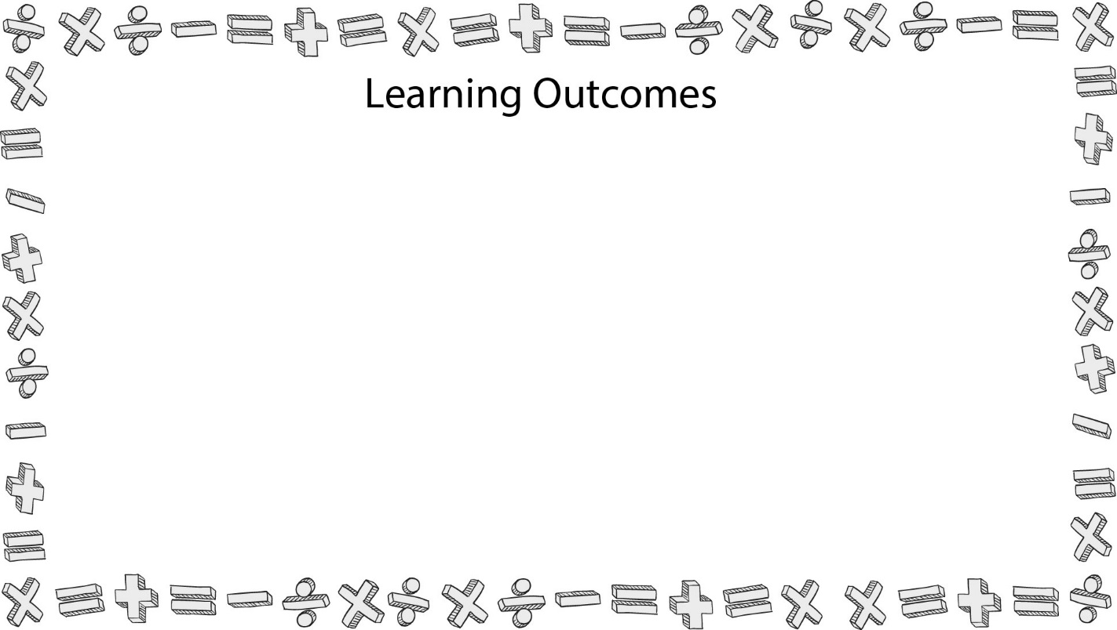
- Differentiate between the three primary methods used by communication researchers—quantitative, critical, and qualitative.
- Understand the purpose of grounded theory in communication research.
- Be able to explain the purposes of open-ended questions, focus groups, participation observation, and unobtrusive measures; when researchers should use these qualitative methods; and what kinds of results are generated.
- Be able to explain the purposes of triangulation or multiple class measurements, when researchers should use this qualitative method, and what kinds of results are generated.
- Explain the four ethical issues commonly discussed in qualitative research—informed consent, deception, privacy and confidentiality, and accuracy sent, deception, privacy and confidentiality, and accuracy.

I. Three Threads of Inquiry

A. Quantitative

B. Critical

C. Qualitative

II. Multiple Labels for One Research Method

A. Naturalistic

B. Qualitative

C. Interpretive/Interpretivist

D. Ethnographic

E. Field

1. Participant field research

2. Nonparticipant field research

F. Action/Applied

III. Five Commonly Shared Characteristics of All Forms of Qualitative Research

A. Natural Setting

B. Research as Participant

C. Subject-Based Communication

D. Subject Intentionality

E. Pragmatism

IV. Grounded Theory

V. Reactivism

A. Guinea Pig Effect

B. Role Selection

C. Measurement as Change Agent

D. Response Sets

E. Interviewer Effects

F. Change in the Research Instrument

G. Population Restrictions

H. Population Stability

I. Dross Rate

J. Ability to Replicate

VI. Qualitative Research Methods

A. Open-Ended Questions

B. Focus Groups

C. Participant Observation

D. Unobtrusive Measures

E. Triangulation/Multiple Class Measurements

VII. Ethics Redux

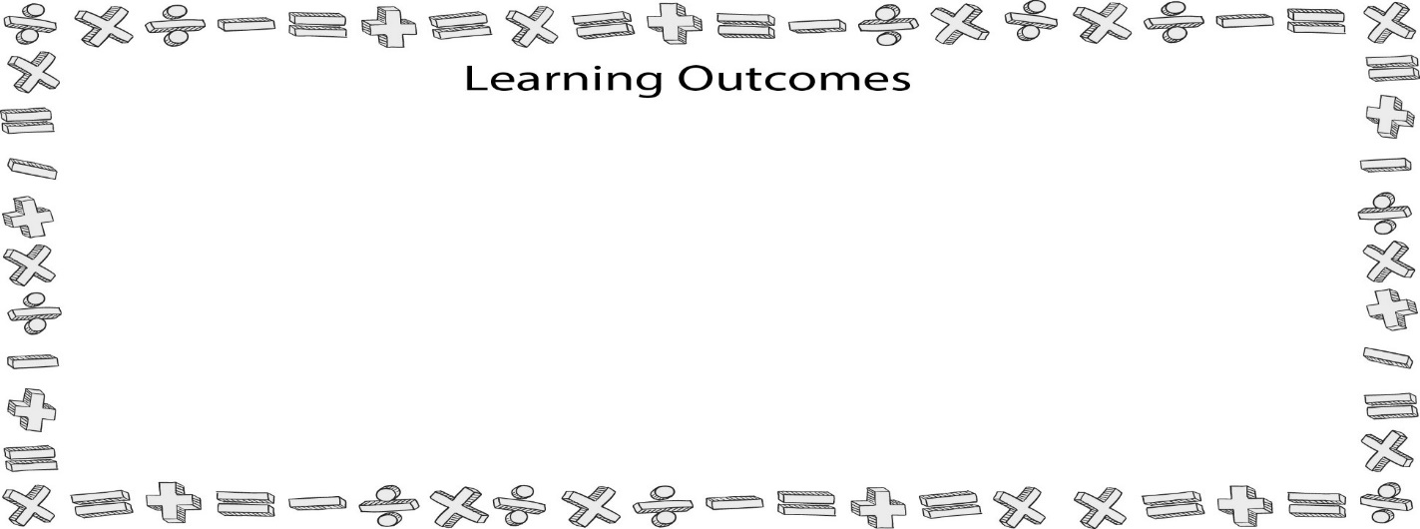
Appendix D: Big Data
- Differentiate among the terms Big Data, machine learning, data science, and data analytics.
- Explain Doug Laney’s three V’s of Big Data.
- Explain Mark van Rijmenam’s additional four V’s of Big Data.
- Differentiate among methods researchers can utilize to evaluate Big Data.
- Critique various issues related to the ethical use of Big Data.

I. Big Data Examples

A. Our World Today

B. Target

C. Apple’s Smart Watch

D. Editd

E. Call of Duty

II. Big Data

A. Big Data

1. Too large to store on a single computer

2. Beyond the scope of traditional statistical software

B. What Is Big Data?

1. Human-Generated Data

2. Metadata

a. Definition

b. Examples

3. Machine-Generated Data

a. Definition

b. Examples

c. Internet of Things (IoT)

C. Big Data Explained

1. Machine Learning

2. Data Science

3. Data Analytics

4. Descriptive analytics

5. Prescriptive Analytics

D. Laney’s 3 Vs

1. Volume

2. Velocity

3. Variety

E. van Rijmenam’s Four Vs

1. Veracity

2. Variability

3. Visualization

4. Value

F. Big Data and the Cloud

G. Understanding the Cloud

H. The Cloud and Data

1. Scalability

2. Redundancy

3. Speed

I. Big Data in the Cloud

1. Infrastructure as a service

2. Platform as a service

3. Software as a service

4. Data as a service

III. Big Data Analysis

A. Data mining

1. Example

B. Data dredging/fishing

1. Example

C. Monitoring and Anomalies

1. Monitoring

2. Anomalies

IV. Communication and Big Data

V. Big Data Ethics

A. Privacy

1. Latanya Arvett Sweeney and MA Public Employee Health Data

2. HIPAA

3. Netflix and IMDB

B. Identity

1. Richards and Kind (2014)

2. Multiple identities

3. Symbiotic relationship between identity and privacy

a. Big marketers

C. Ownership

1. Do we own our demographic information, family information, information about hobbies and skills, or individual preferences (Coke vs. Pepsi, plastic vs. paper, etc.)?

2. European data collection vs. U.S. data collection

a. The European Union states that individual data can only be collected for legitimate purposes.

D. Reputation

1. Davis and Patterson (2012)

2. Should an individual’s reputation be based on what the individual viewed online?

3. Companies that manage online reputations

E. Manage Your Online Reputation

1. Google yourself

2. Buy your domain name

3. Join social networks

4. Optimize your presence. You want people to find you.

5. Keep your private things private.

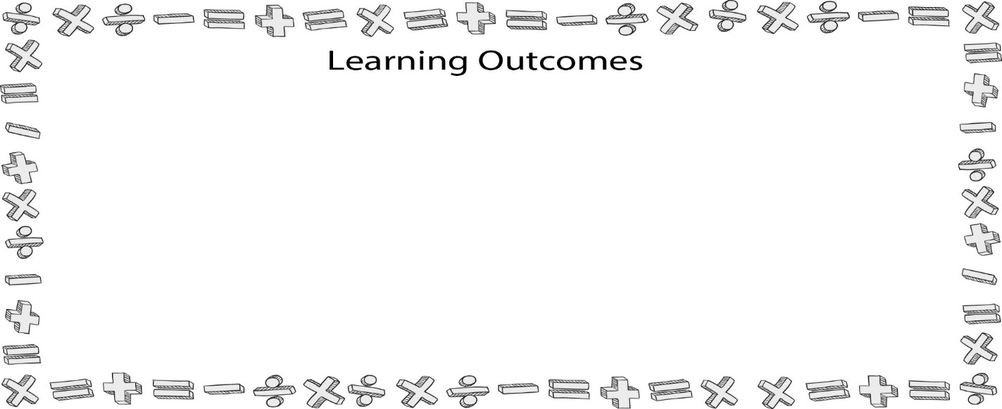
Appendix E: Advanced Statistical Tests
- Explain the Law of Parismony.
- Summarize a series of different statistical analysis of variance (ANOVA) tests: factorial ANOVA, analysis of covariance (ANCOVA), multivariate ANOVA (MANOVA), and repeated-measures ANOVA.
- Evaluate a range of advanced statistical tests that analyze relationships: path analysis, structural equation models, factor analysis, and canonical correlations.

I. Law of Parsimony

II. Difference Tests

A. Factorial ANOVA

1. Types of variables examined

a. Two or more nominal independent variables (IVs)

b. One interval/ratio dependent variable (DV)

2. Example

a. Biological sex (female and male) and political affiliations (Democrat,
Republican, other, and not registered to vote) as the IVs

b. College students’ attitudes toward college (measured by a semantic
differential scale, so it is an interval variable) as the DV

3. Explanation of the factorial ANOVA

a. The IVs are referred to as factors

b. In the example above, there are two levels in the first factor (male and female) and four levels in the second factor (Democrat, Republican, other, and not registered to vote).

c. This design then would be considered a 2 × 4 factorial ANOVA.

d. Difference tests conducted by a factorial ANOVA

i. First main effect

ii. Second main effect iii. Interaction effect

4. APA write-up

5. Explanation of results

B. ANCOVA

1. Types of variables examined

a. One or nominal IV

b. One interval/ratio DV

c. One interval/ratio covariate

2. Example

a. Biological sex (female and male) as the IV

b. Communication (measured by a 24-item Likert scale, so it is an interval variable) as the DV

c. Willingness to communicate (an interval variable) as the covariate

3. Explanation of the ANCOVA

a. The purpose of an ANCOVA is to allow a researcher to determine if a difference lies between groups (female and male) on a DV communication apprehension) after the DV has been mathematically adjusted for differences associated with one or more covariates (willingness to communicate).

b. The basic test analyzed in an ANCOVA is the same in a one-way ANOVA: Is there a difference between groups?

c. Covariate defined

4. APA write-up

5. Explanation of results

C. MANOVA

1. Types of variables examined

a. One or more nominal IVs

b. Two or more interval/ratio DVs

2. Example

a. Perhaps a researcher wanted to see if females and males differ in their levels of ethnocentrism but also if males and females differ in their levels of willingness to communicate (WTC) with strangers.

b. Females and males (a nominal variable) would be the IV.

c. Ethnocentrism (an interval variable) and WTC (an interval variable) would be the DVs.

3. Explanation of the MANOVA

a. Multivariate tests have multiple DVs. b. Univariate tests have one DV.

c. Often the DVs analyzed in a MANOVA are different measures of the same phenomenon.

d. The two DVs do not need to be related, but they should share a common conceptual meaning and some degree of linearity.

4. APA write-up

5. Explanation of results

D. Repeated Measures ANOVA

1. Types of variables examined

a. The IVs are not measured but are time sequences: Time 1, Time 2, Time 3 . . . Time X.

b. One interval/ratio DV (measured repeatedly)

2. Example

a. Suppose you’re a public speaking teacher and you wanted to determine if taking a public speaking course actually decreases a person’s level of communication apprehension (CA).

b. One possible way to determine if a person’s level of CA decreases over the course of a public speaking class would be to test his or her CA level at the beginning of the course, again halfway through the course, and a third time at the end of the course.

c. Each measurement of CA is a DV measurement.

d. You could calculate three paired t tests to determine this research question (Time 1 to Time 2, Time 2 to Time 3, and Time 1 to Time 3), but again the more tests you run the more error your findings will have.

e. In order to avoid increasing your Type I error, you can run a procedure called a repeated measures ANOVA.

3. Explanation of repeated measures ANOVA

a. A repeated measures ANOVA allows a researcher to determine if differences occur in a variable over time.

b. In the example above, we measure these differences occurring over time by having students fill out the Personal Report of Communication–24 at the beginning of the semester/quarter, in the middle of the semester/quarter, and at the end of the semester/quarter.

c. By having the students fill out the survey all three times, we have a way of mapping what happens to CA levels throughout the course of a public speaking class.

d. What we are testing is the null hypothesis that Time 1 (beginning of the semester/quarter) = Time 2 (middle of the semester/quarter) = Time 3 (end of the semester/quarter), or H0: CATime1 = CATime2 = CATime3.

4. APA write-up

5. Explanation of results

III. Relationship Tests

A. Canonical Correlations

1. Types of variables examined

a. Two or more interval/ratio IVs

b. Two or more interval/ratio DVs

2. Example

a. CA (group, meeting, interpersonal, and public)

b. WTC (group, meeting, interpersonal, and public)

3. Explanation of the canonical correlation

a. A canonical correlation is a statistical tool that can help a researcher investigate the relationships among two or more variable sets.

b. In our example, we have two different variable sets: CA (group, meeting, interpersonal, and public) and WTC (group, meeting, interpersonal, and public).

4. APA write-up

5. Explanation of results

B. Path Analysis

1. Types of variables examined

a. Two or more interval/ratio IVs

b. Two or more interval/ratio DVs

2. Example

a. Perhaps you want to determine the causal relationships between CA, ethnocentrism, humor assessment, attitudes toward college, and people’s belief that everyone should be required to take public speaking in college.

b. Path analysis picture (See Figure E.2)

3. Explanation of path analysis

a. Endogenous and exogenous

i. Endogenous defined

ii. Exogenous defined

4. APA write-up

5. Results explained

C. Structural Equation Modeling

1. Types of variables examined

a. Two or more interval/ratio IVs

b. Two or more interval/ratio DVs

2. Proposed Structural Model (See Figure E.4)

3. Explanation of the factorial ANOVA

a. Structural equation modeling is very similar in its purpose to path analysis; however, the calculations are considerably more difficult but mathematically more meaningful.

b. Observed and latent variables

i. Observed variable defined

ii. Latent variable defined

c. Exogenous and endogenous variables

i. Exogenous latent variables

ii. Endogenous latent variables

4. APA write-up

5. Results explained

D. Factor Analysis

1. Types of variables examined

a. Two or more items from an interval scale (most common)

b. Two or more interval variables (least common)

2. Example

a. In 2001, Richmond, Wrench, and Gorham created a new research scale to measure an individual’s use of humor during interpersonal interactions.

b. The scale itself consists of 16 Likert-type items using a 5-point scoring system from 1 “strongly disagree” to 5 “strongly agree.”

c. How do we know that these 16 items actually measure anything? As we discussed in Chapter 10, the Humor Assessment instrument has an alpha reliability of 0.92 (M = 62.06, SD = 9.82).

d. We know the scale is reliable, but do the 16 items in the Humor Assessment instrument actually measure just one thing?

3. Explanation of the factorial ANOVA

a. A factor analysis is a technique that enables researchers to determine variation and covariation among research measures.

b. The purpose of a factor analysis is to determine how many different variables are being measured by a set of questions on a research scale.

c. Two types of factor analysis

i. Exploratory factor analysis (EFA)

ii. Confirmatory factor analysis (CFA)

4. APA write-up

5. Results explained

6. Factor analysis with two factors

