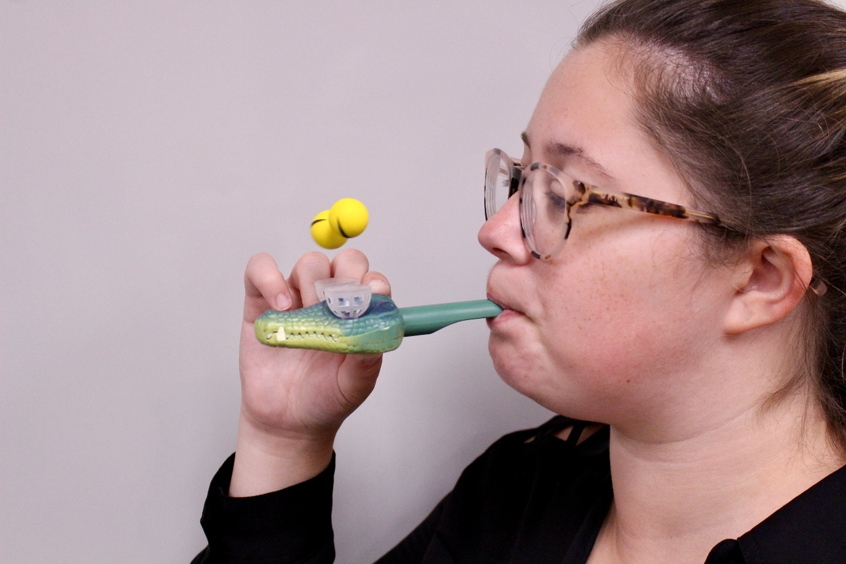
Figure 1. Blowing toys
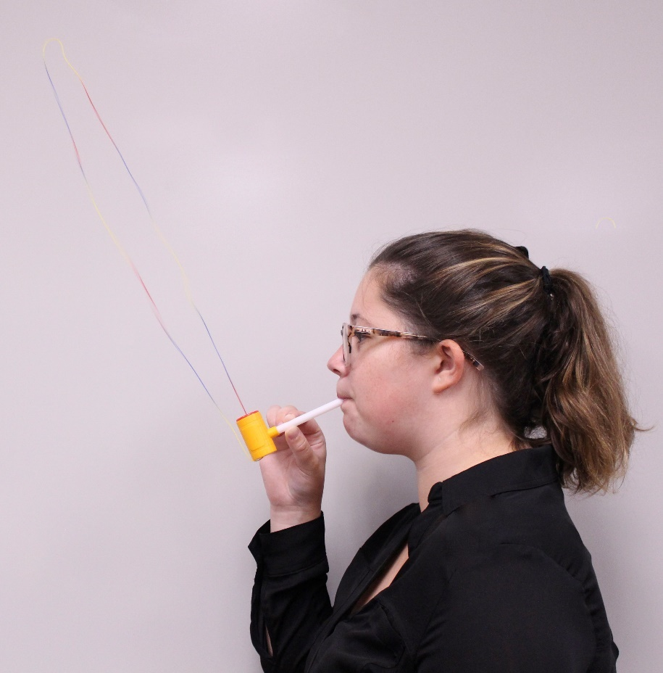
Figure 2. String toys

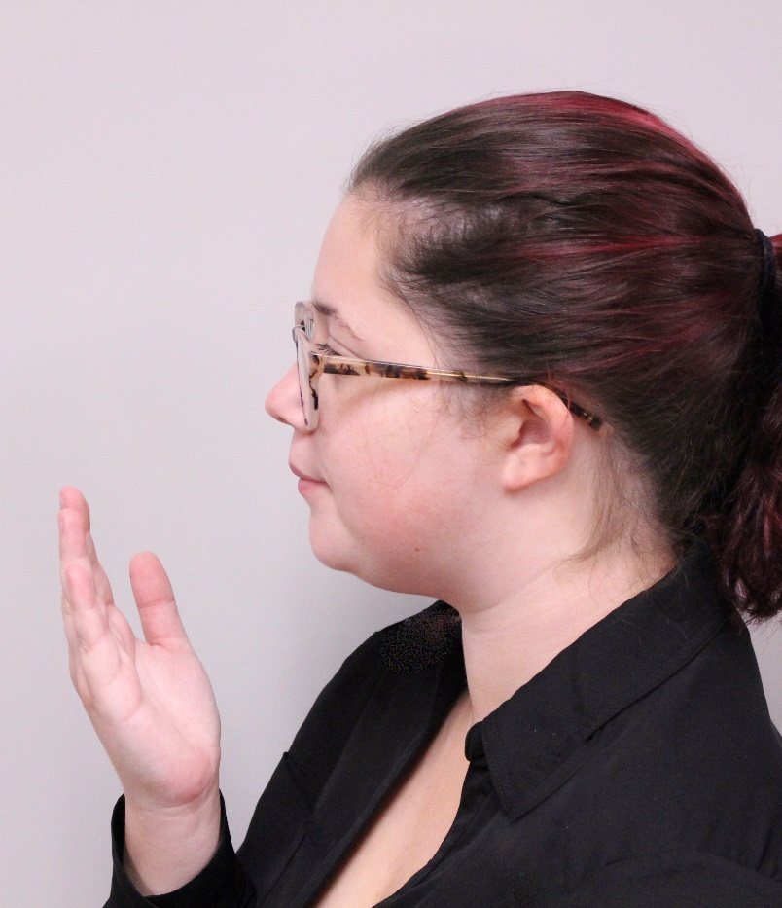
Figure 3. Hand assessing air angle and consistency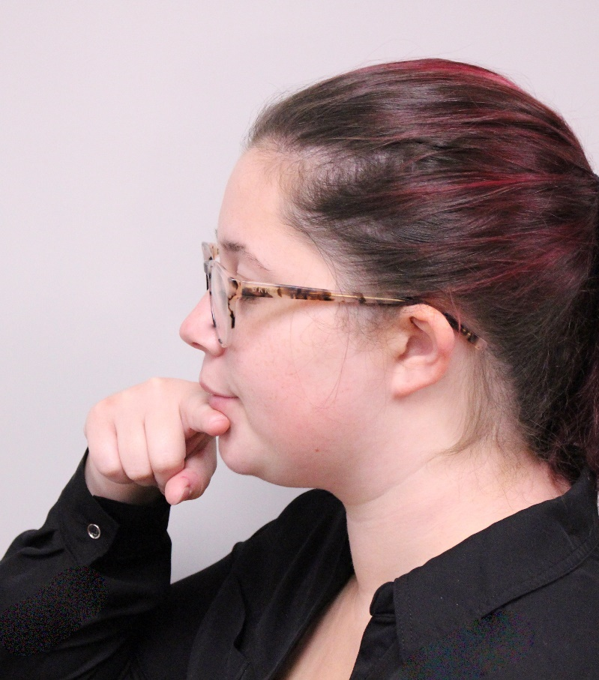
Figure 4. Finger as the lip plate

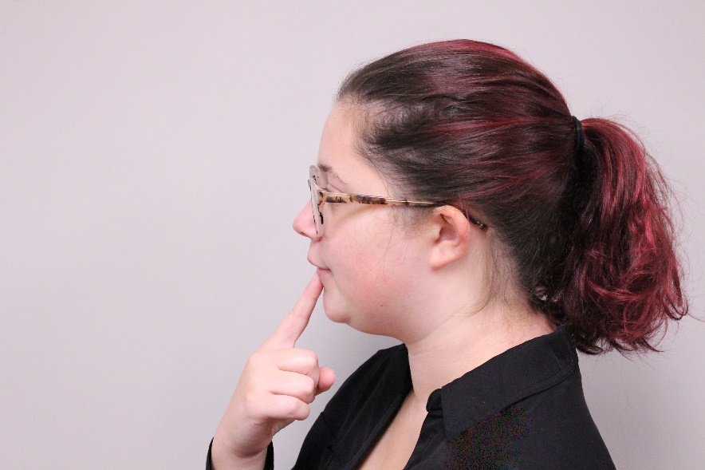
Figure 5. Finger as the angle, version 1
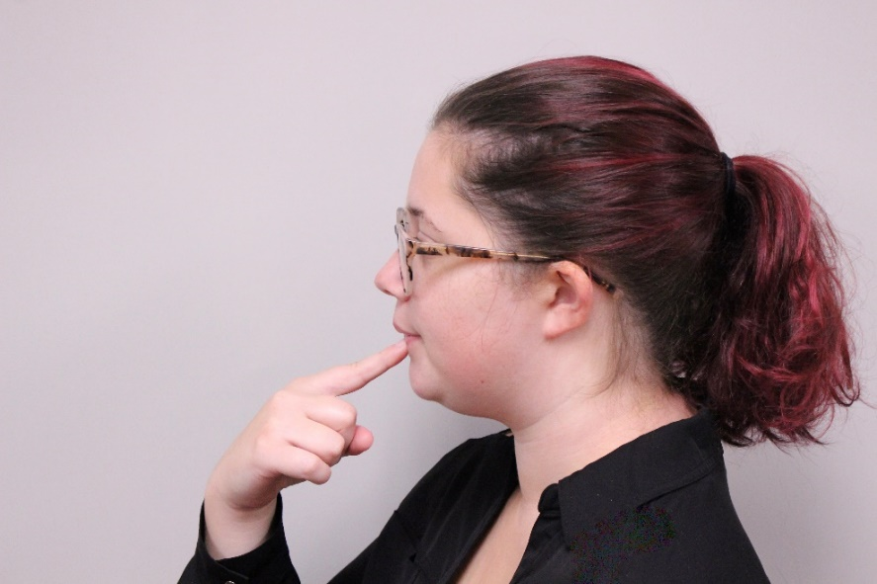
Figure 6. Finger as the angle, version 2
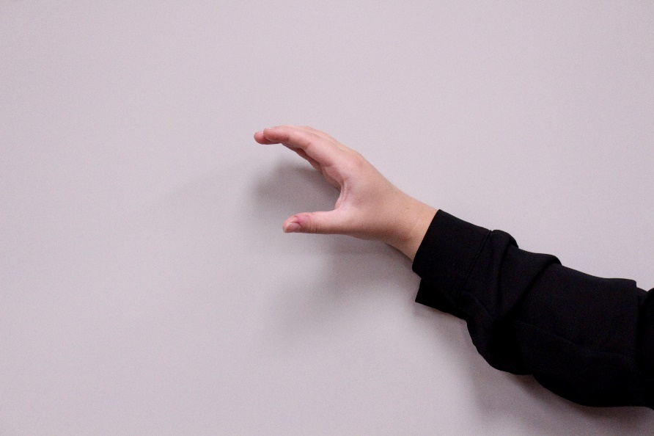
Figure 7. Visual for inside of mouth shape (open)

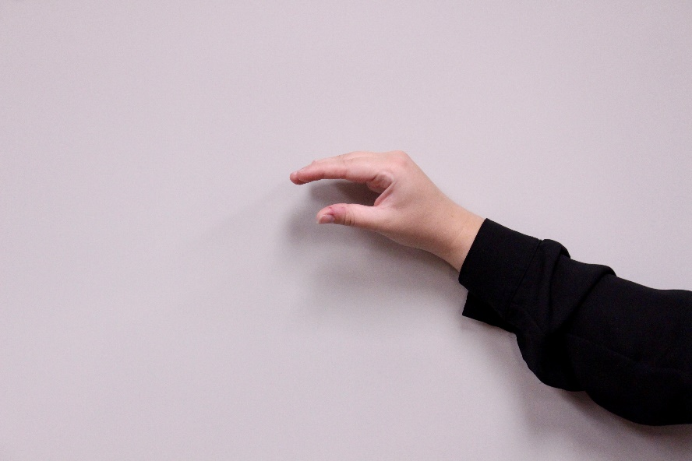
Figure 8. Visual for inside of mouth shape (insect)
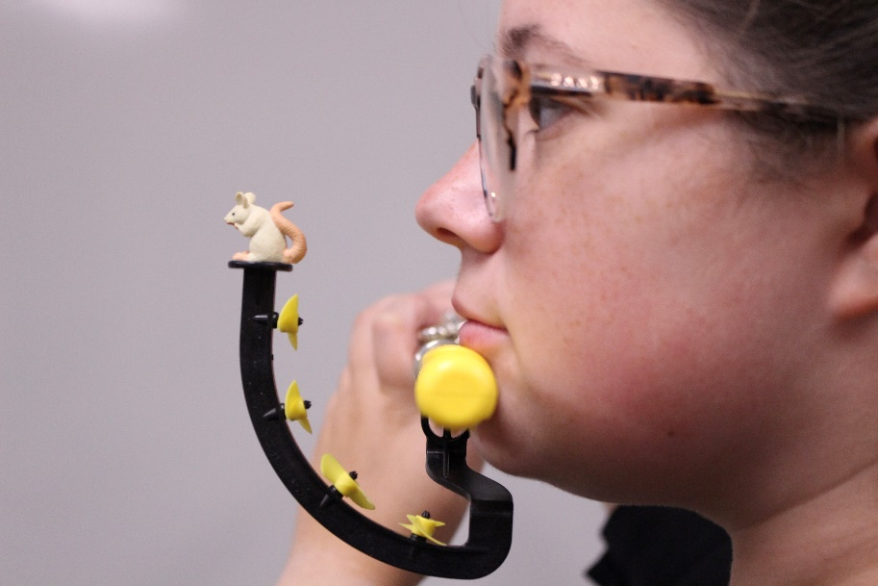
Figure 9. Pneumo pro side angle
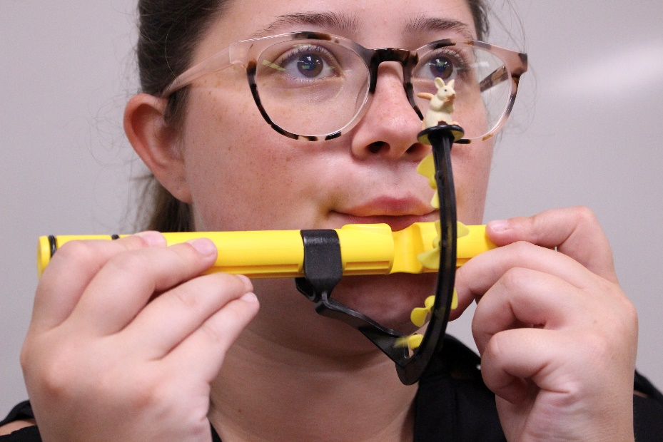
Figure 10. Pneumo pro front angle

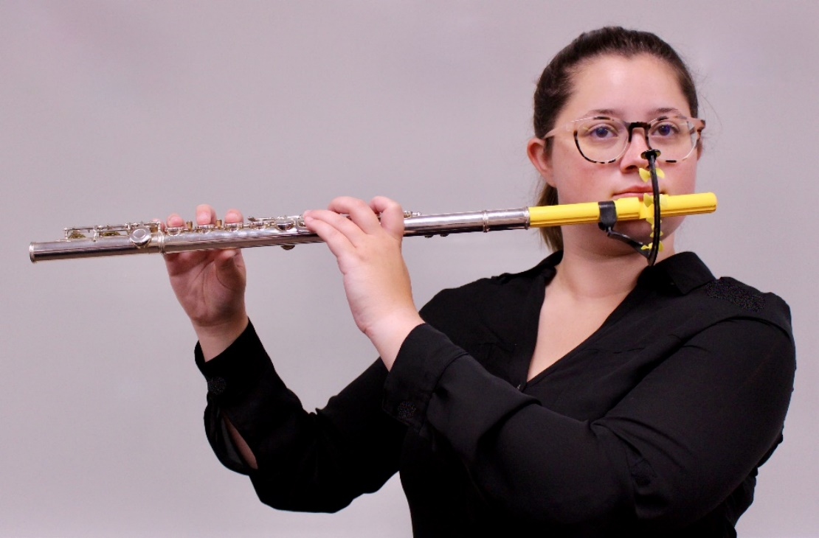
Figure 11. Pneumo pro attached to flute
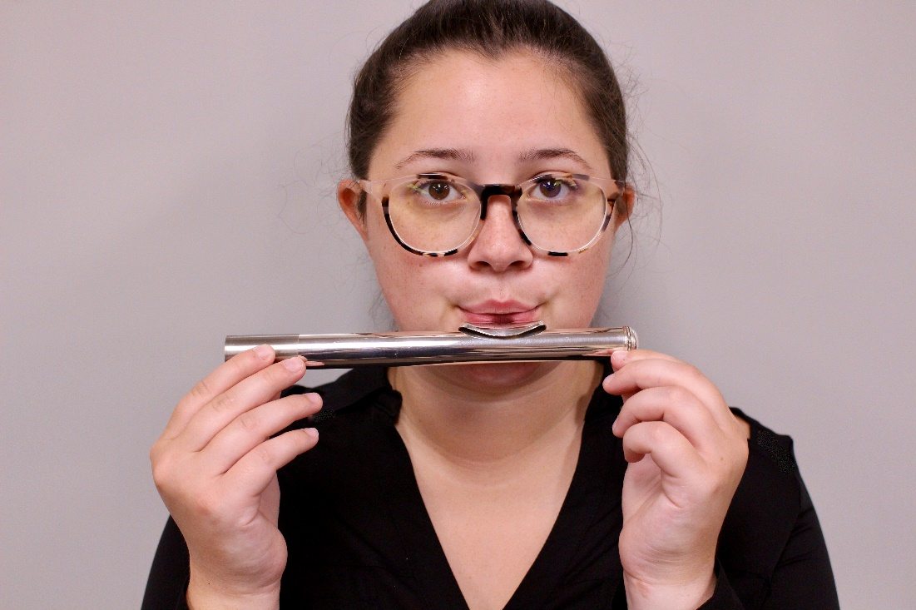
Figure 12. Open headjoint sound
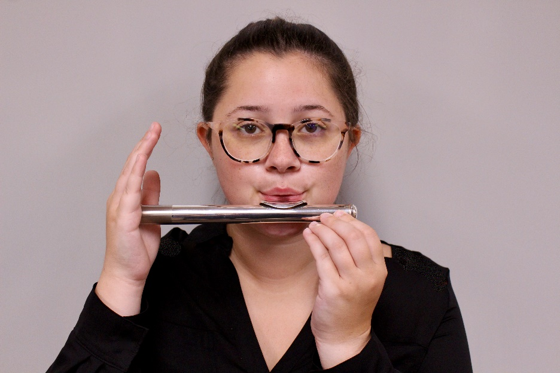
Figure 13. Closed headjoint sound
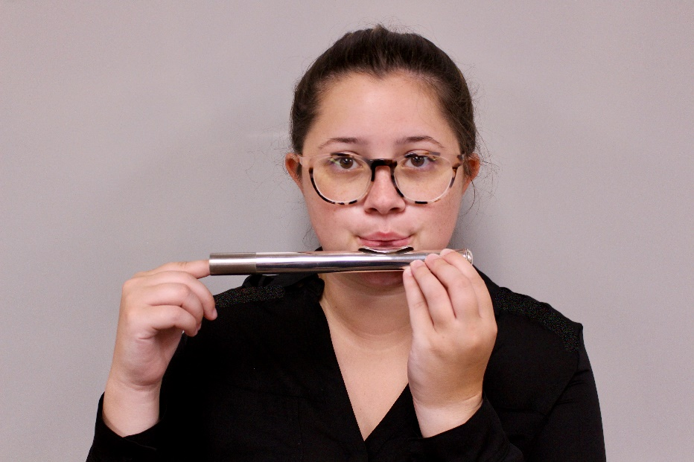
Figure 14. Sliding headjoint sound
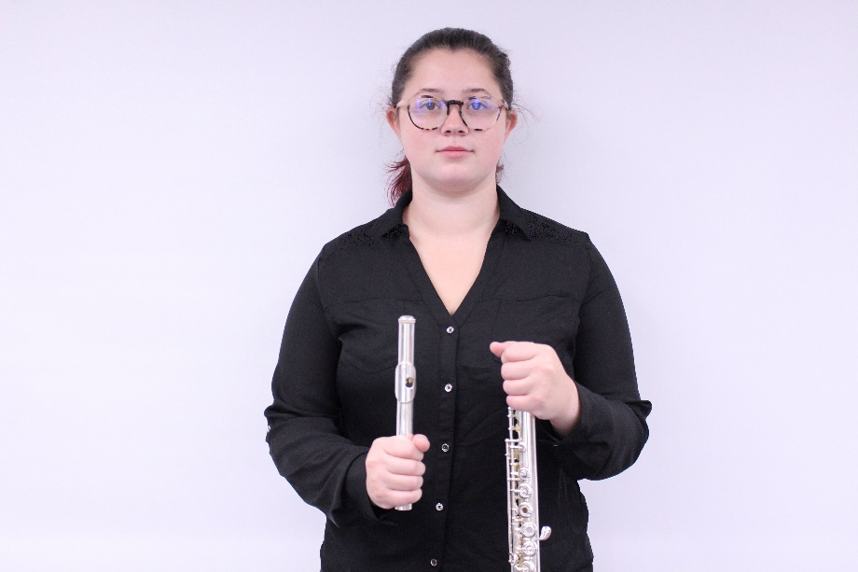
Figure 15. Flute assembly step 1
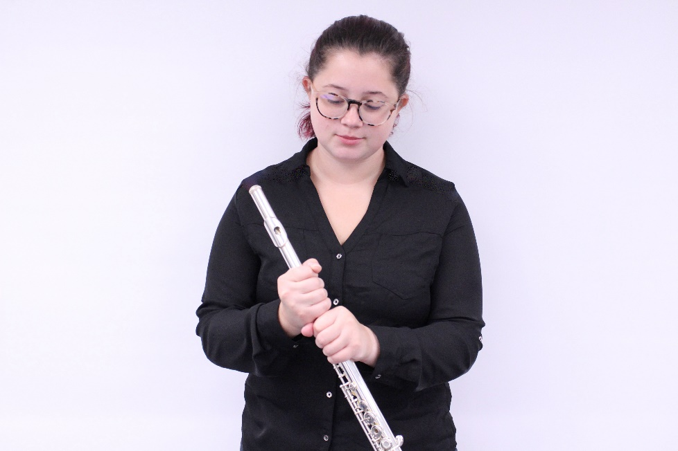
Figure 16. Flute assembly step 2
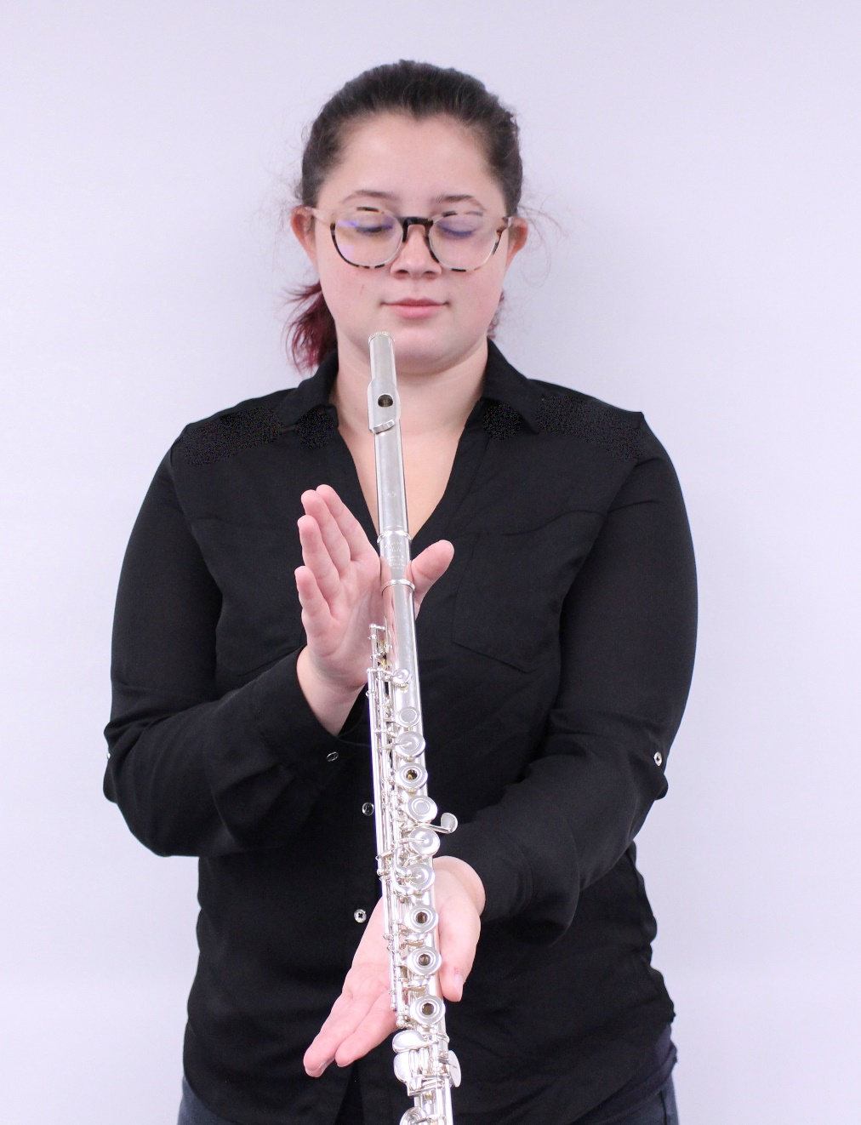
Figure 17. Alignment of the headjoint to body
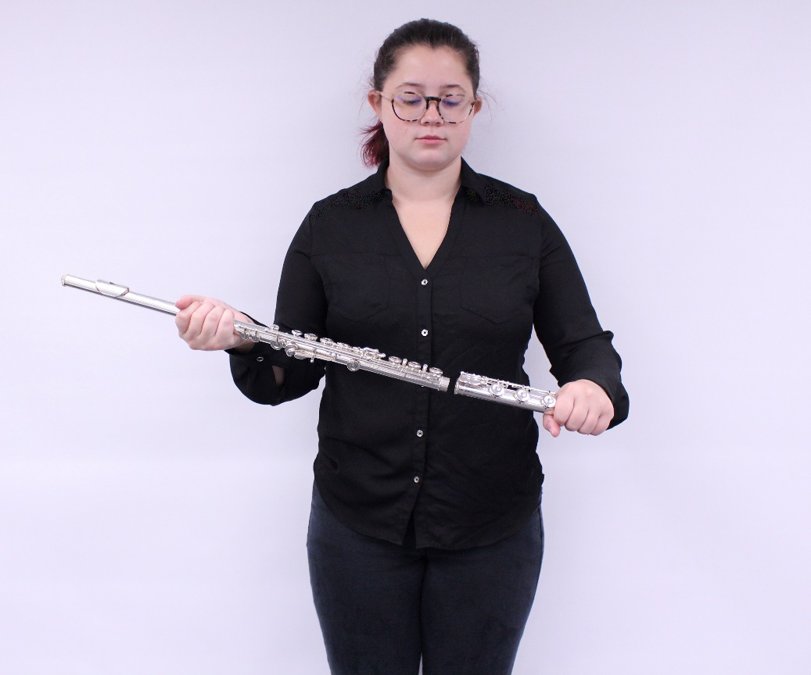
Figure 18. Flute assembly step 3
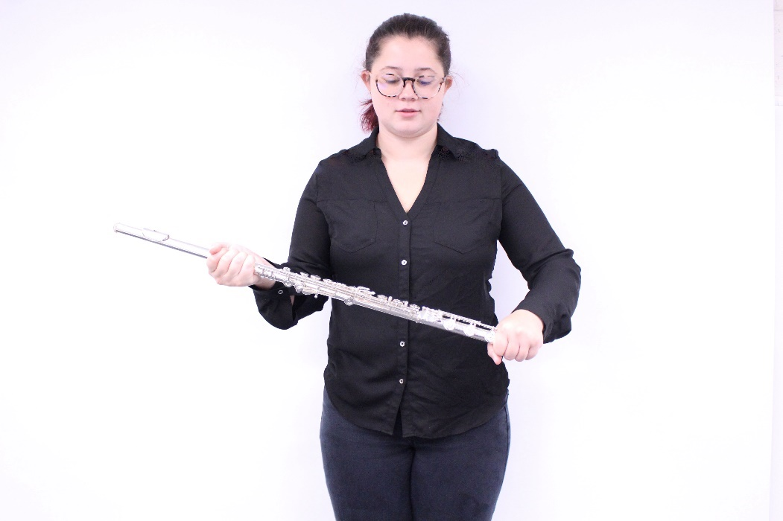
Figure 19. Flute assembly step 4
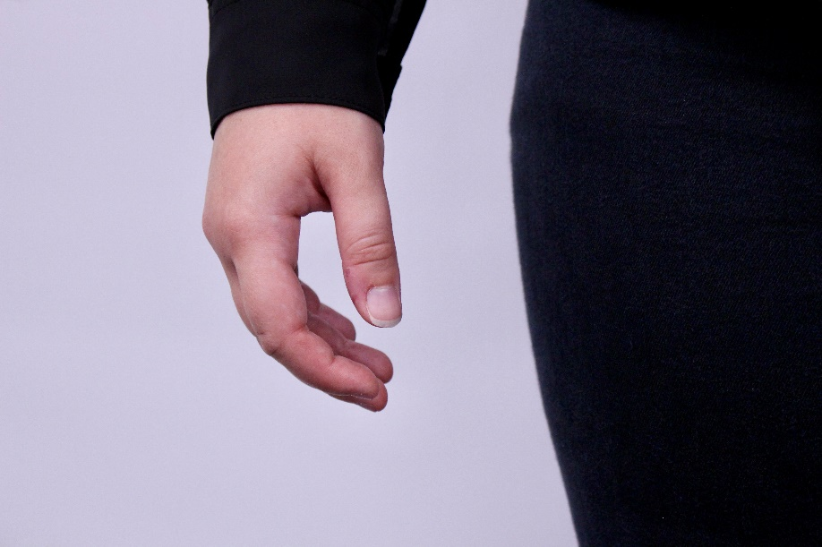
Figure 20. Natural curve of the hand
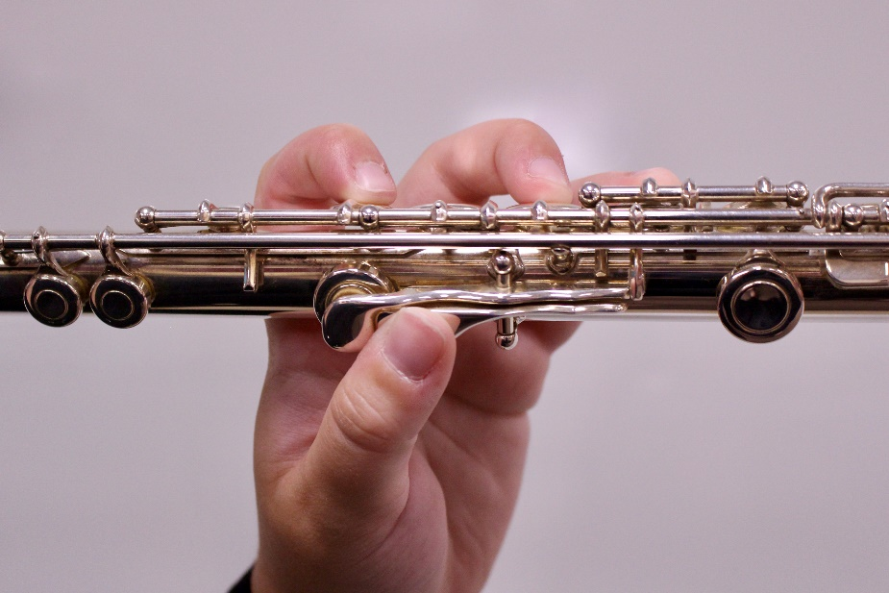
Figure 21. Left hand position
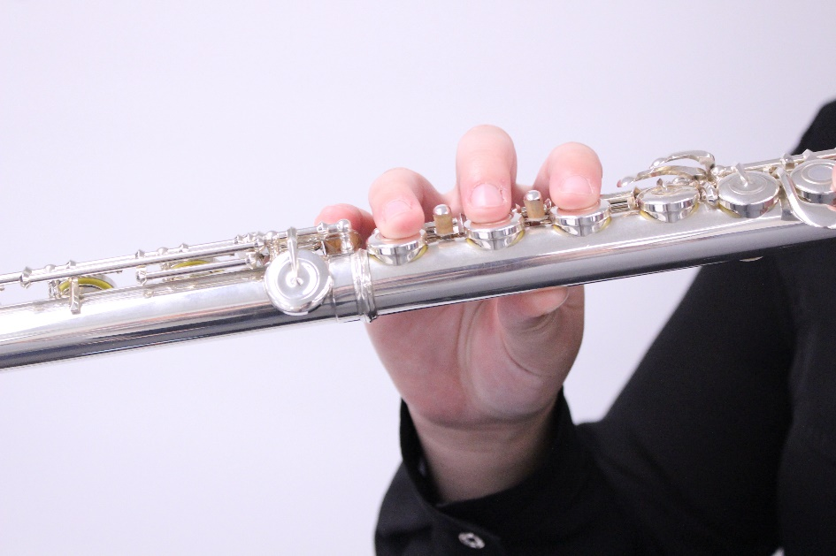
Figure 22. Right hand position
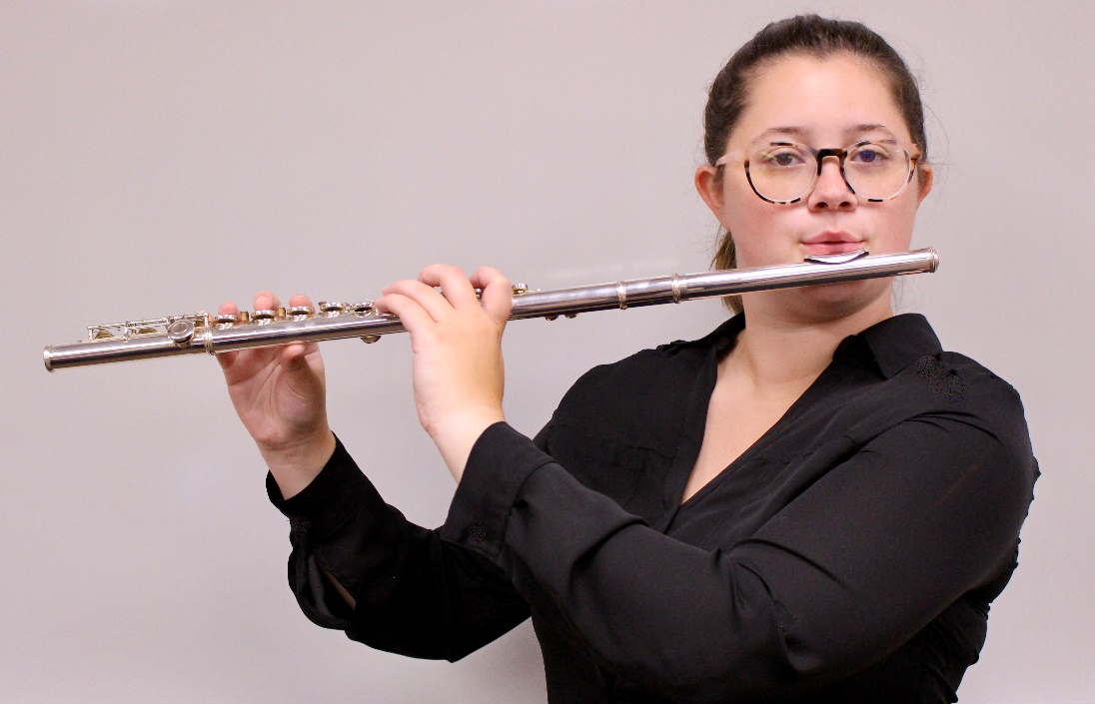
Figure 23. Full hand position

