Figures/Examples for Trombone Chapter

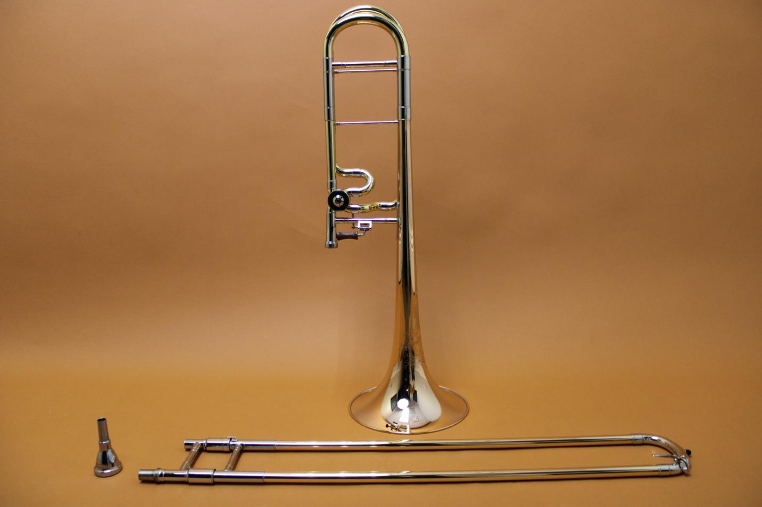
Fig. 41.1
The slide, bell, and mouthpiece

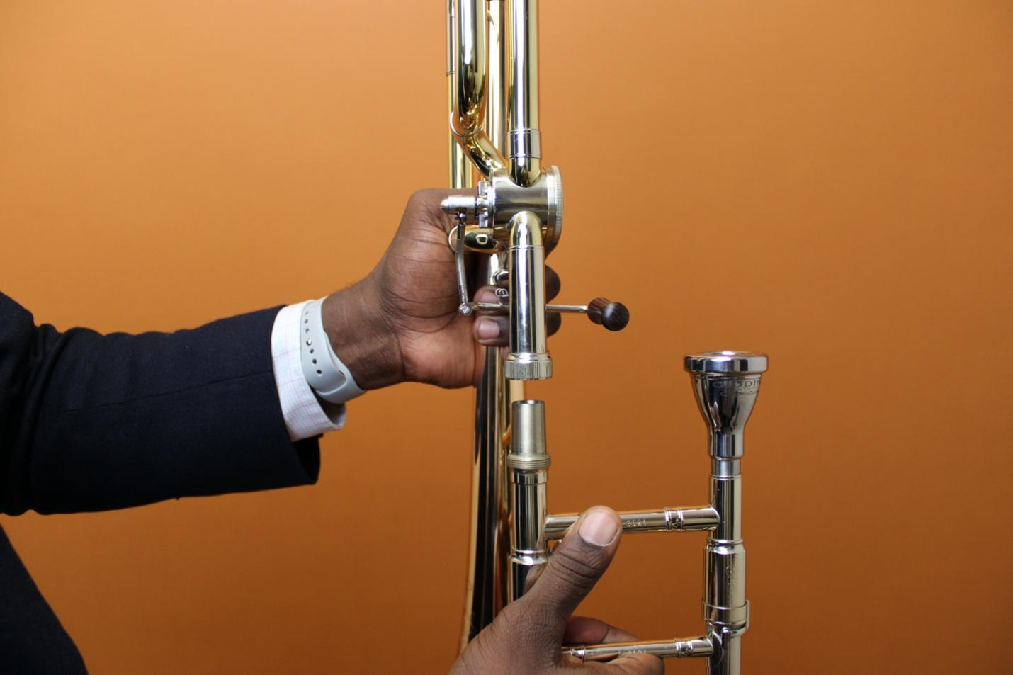
Fig. 41.2
Left hand to grasp bell, right hand on slide.

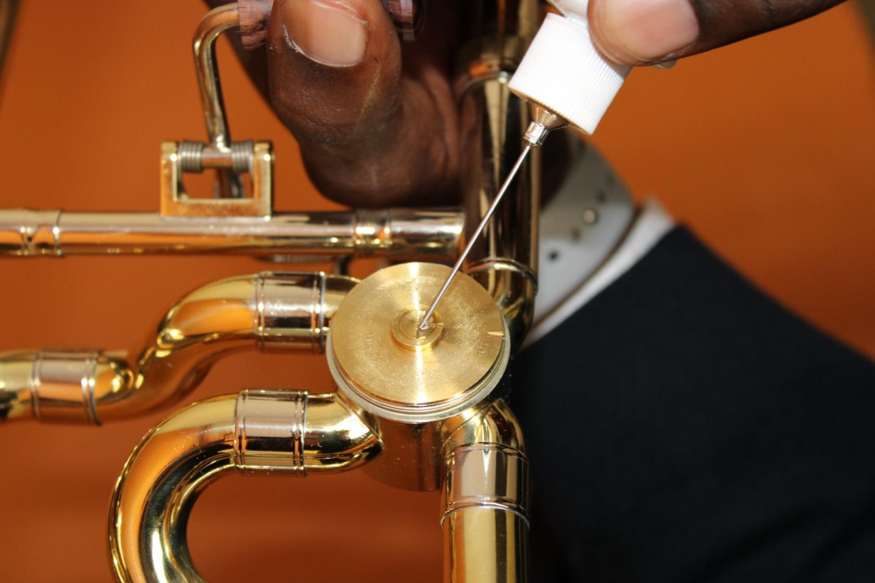
Fig. 41.3
Applying rotor oil through valve mechanism

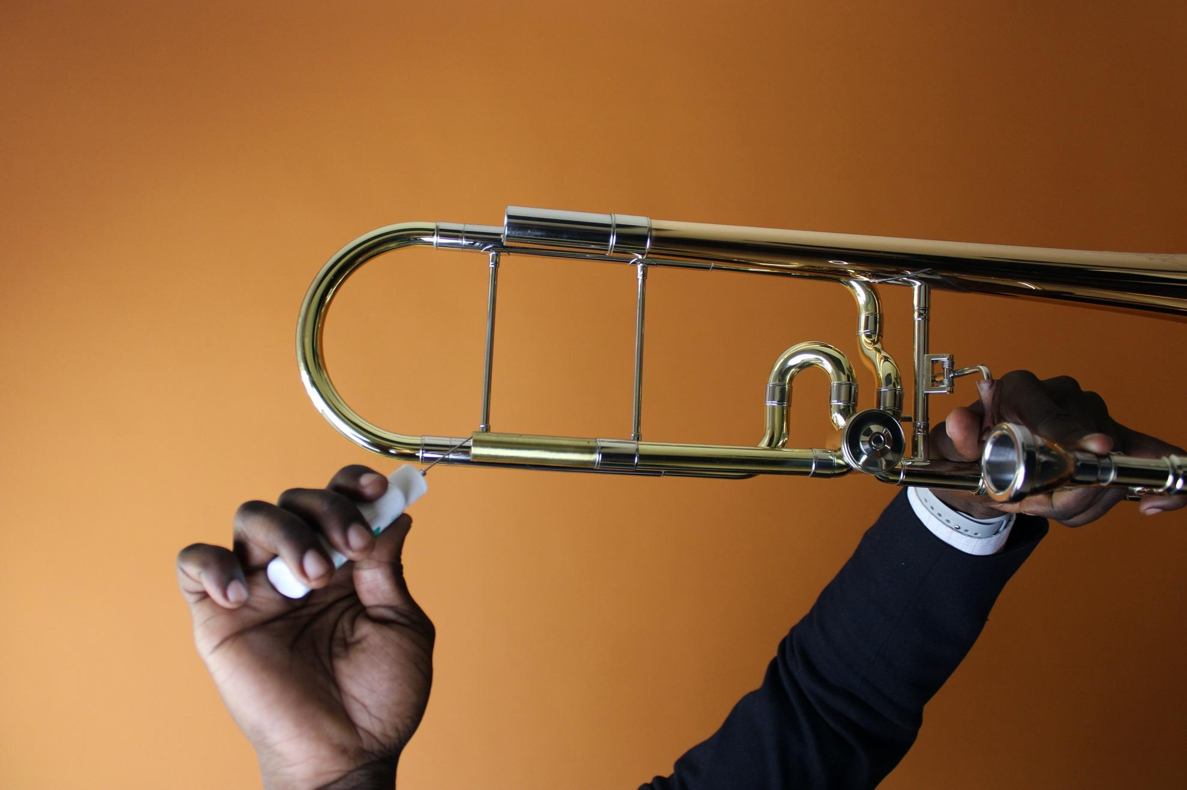
Fig. 41.4
Applying rotor oil through tuning slide



Fig. 41.5
“I Love You” in American Sign Language (ASL)

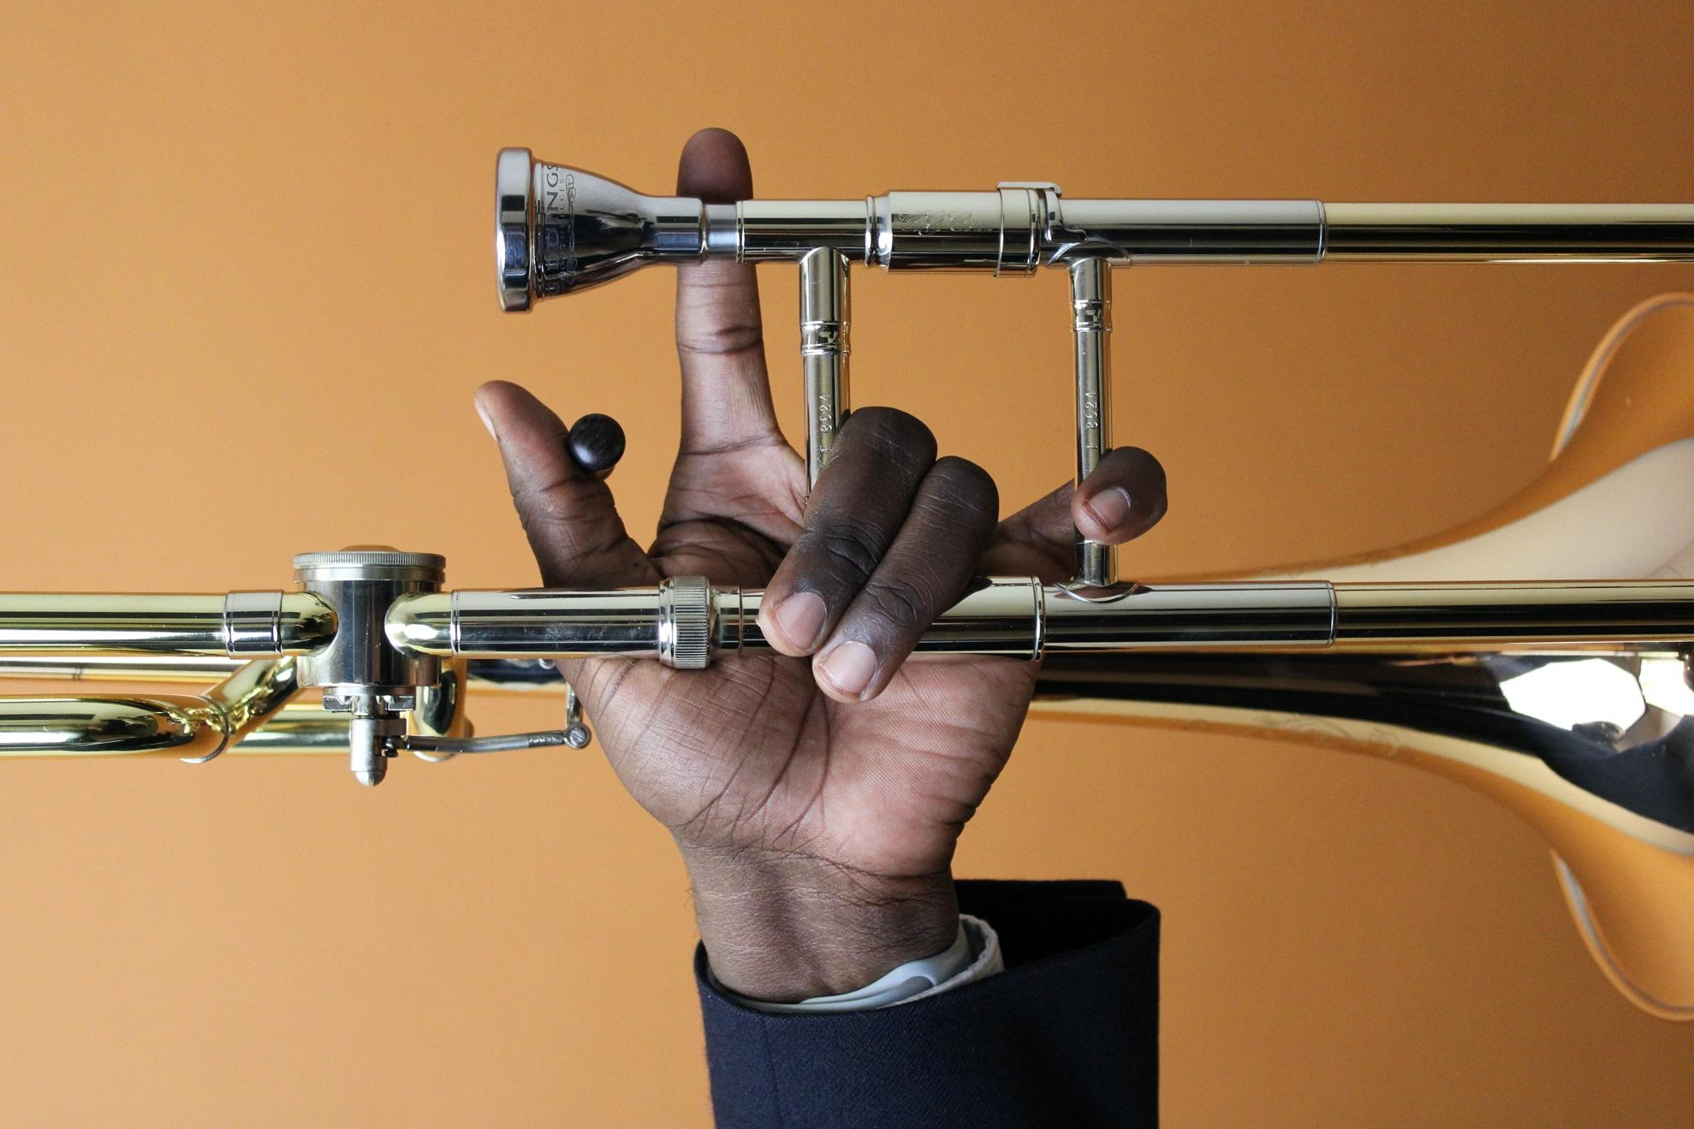

Fig. 41.6
Applying the sign while holding the trombone with left hand.

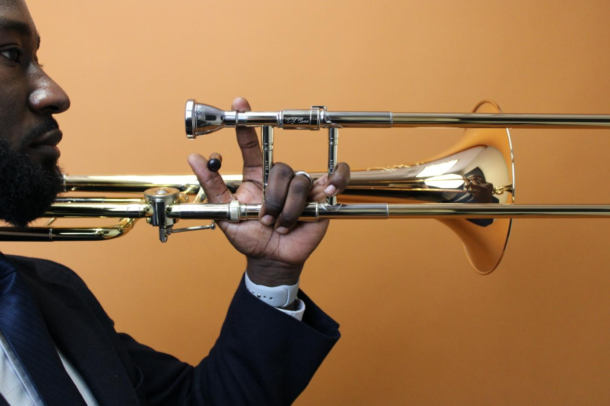
Fig. 41.7
Holding horn with left hand with slide parallel to the ground.

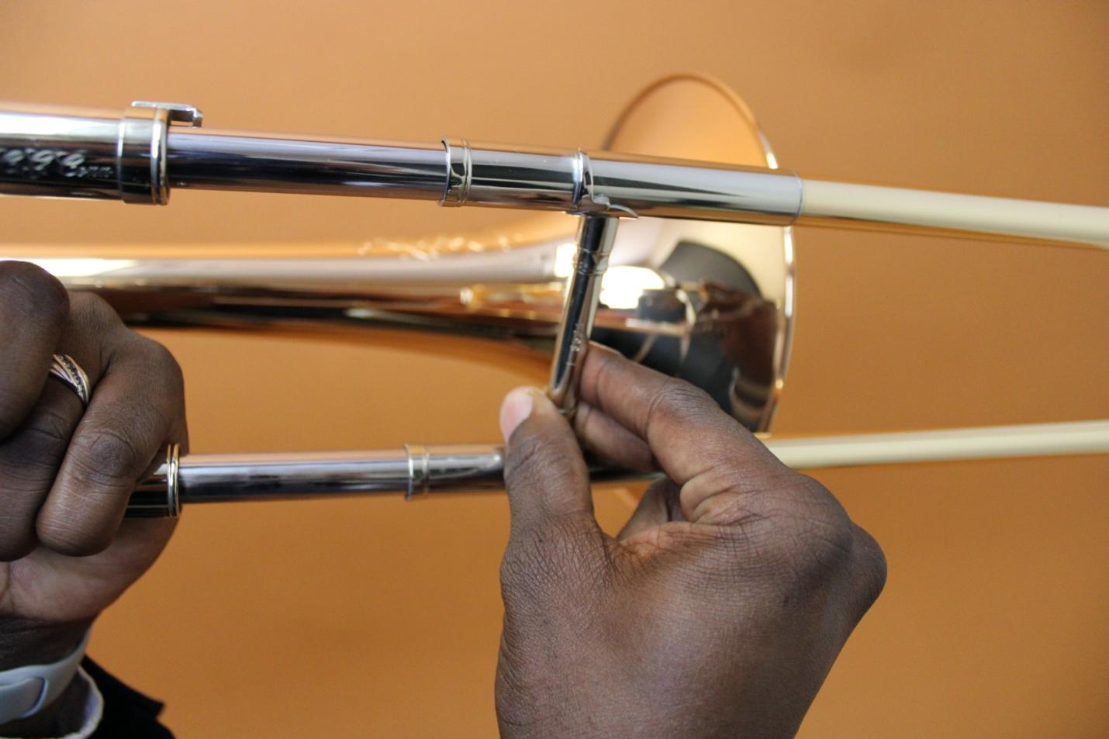
Fig. 41.8
Hold the slide with index, middle and thumb.

Photo courtesy:
Trombone: Conn 88HNV, Conn-Selmer, Inc.
Mouthpiece: “D. Mirvil 5S” Model, Giddings Mouthpieces, Inc.

Notation Examples for Trombone Chapter

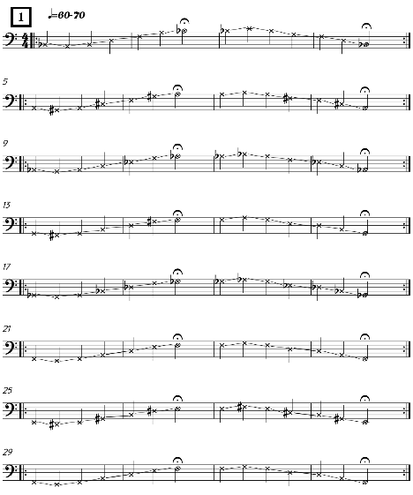

Notation Example 41. 1
Mouthpiece Buzzing Notation Example 1

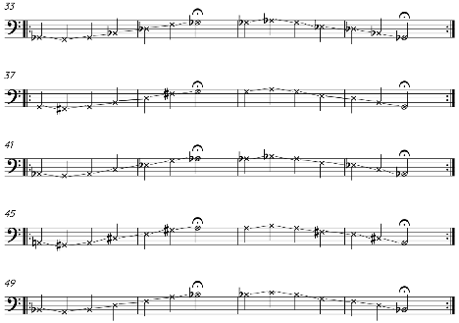

Mouthpiece Buzzing Notation Example 1a

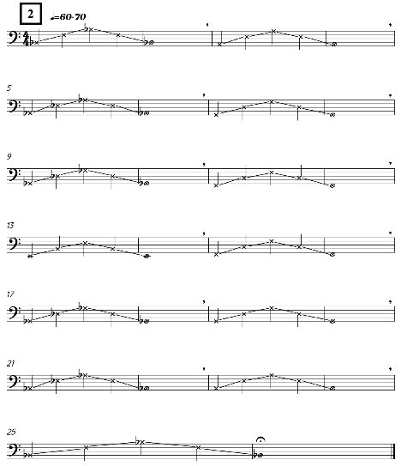

Notation Example 41. 2
Mouthpiece Buzzing Notation Example 2

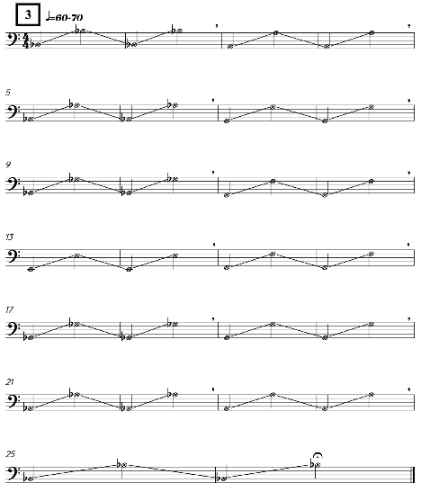

Notation Example 41. 3
Mouthpiece Buzzing Notation Example 3

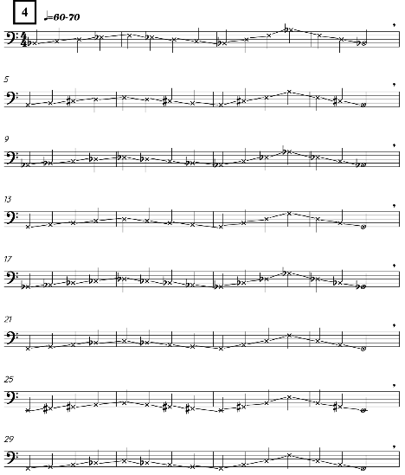

Notation Example 41. 4
Mouthpiece Buzzing Notation Example 4

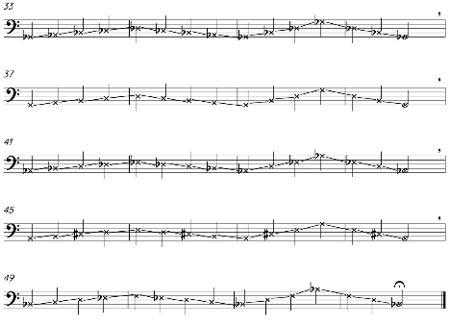

Mouthpiece Buzzing Notation Example 4a

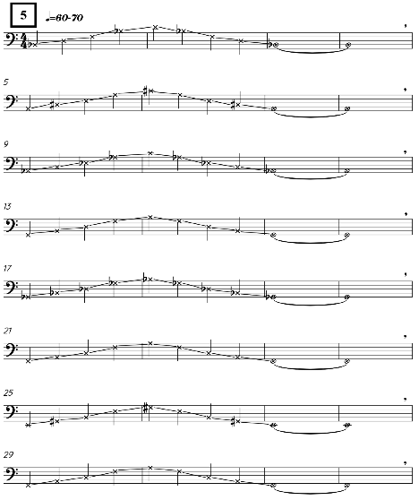

Notation Example 41. 5
Mouthpiece Buzzing Notation Example 5

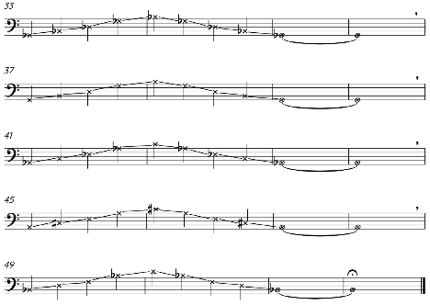

Mouthpiece Buzzing Notation Example 5a

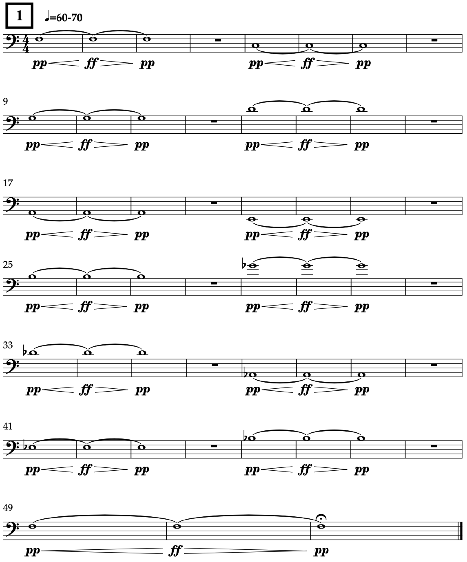

Notation Example 41. 6
Long Tones Notation Example 1

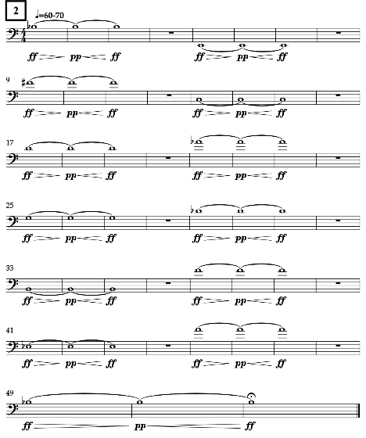

Notation Example 41. 7
Long Tones Notation Example 2

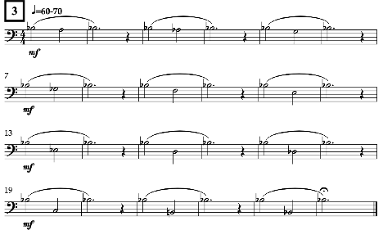

Notation Example 41. 8
Long Tones Notation Example 3

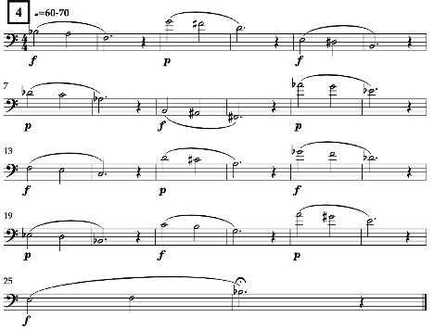

Notation Example 41. 9
Long Tones Notation Example 4

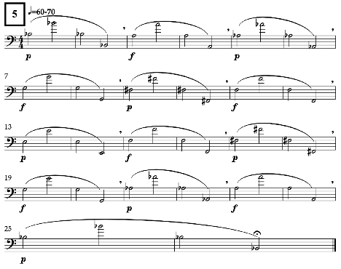

Notation Example 41. 10
Long Tones Notation Example 5

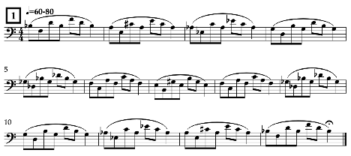

Notation Example 41. 11
Lip Slur Notation Example 1

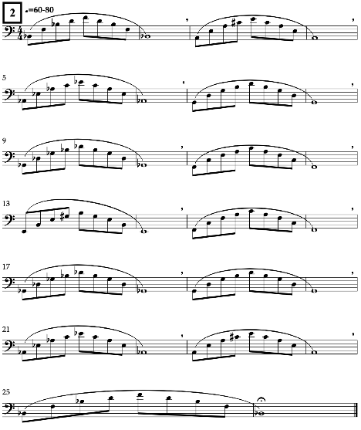

Notation Example 41. 12
Lip Slur Notation Example 2

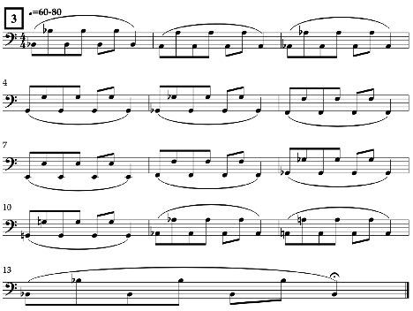

Notation Example 41. 13
Lip Slur Notation Example 3

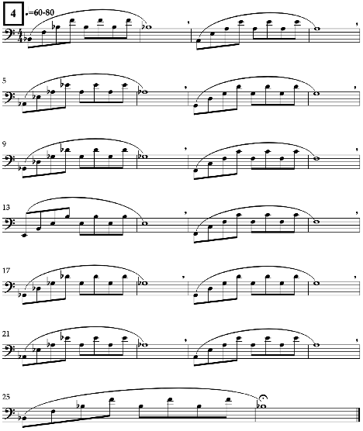

Notation Example 41. 14
Lip Slur Notation Example 4

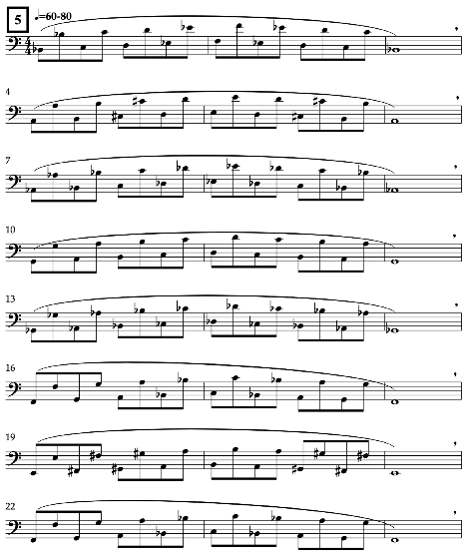

Notation Example 41. 15
Lip Slur Notation Example 5

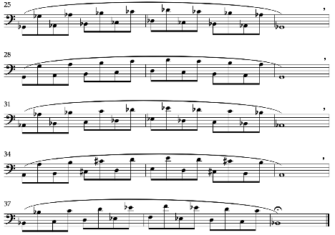

Lip Slur Notation Example 5a

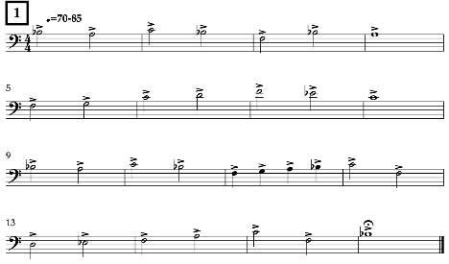

Notation Example 41. 16
Articulation Notation Example 1

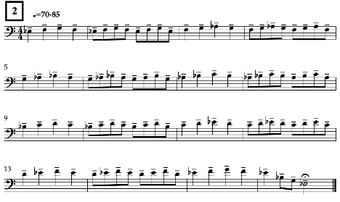

Notation Example 41. 17
Articulation Notation Example 2

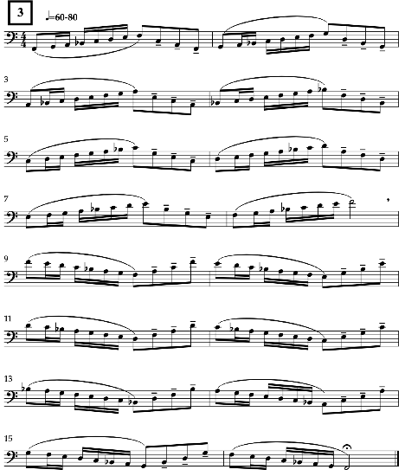

Notation Example 41. 18
Articulation Notation Example 3

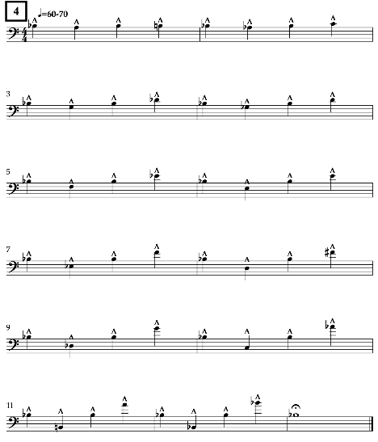

Notation Example 41. 19
Articulation Notation Example 4

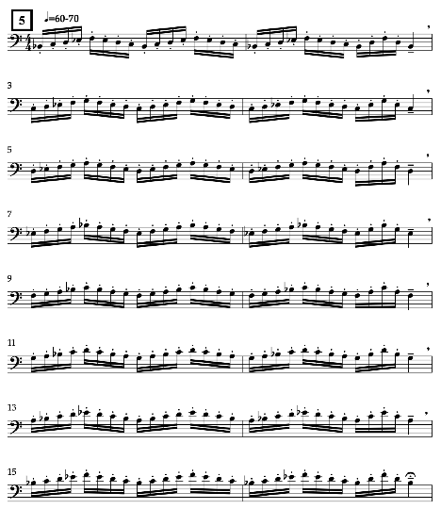

Notation Example 41. 20
Articulation Notation Example 5

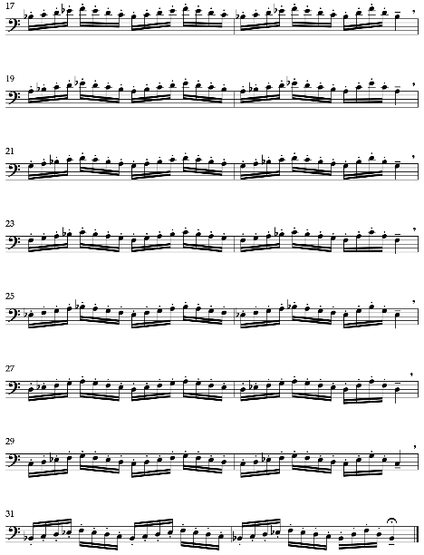

Articulation Notation Example 5a

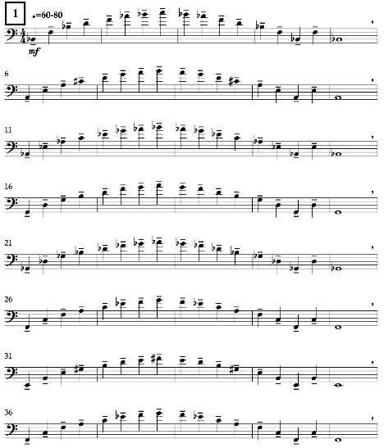

Notation Example 41. 21
Range Notation Example 1

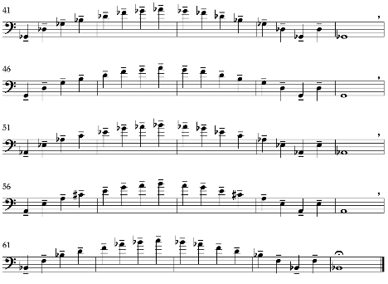

Range Notation Example 1a

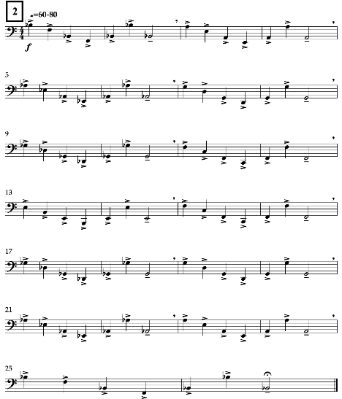

Notation Example 41. 22
Range Notation Example 2

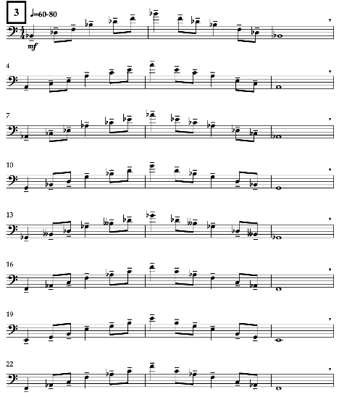

Notation Example 41. 23
Range Notation Example 3

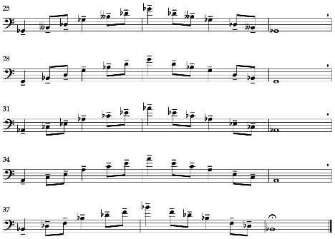

Range Notation Example 3a

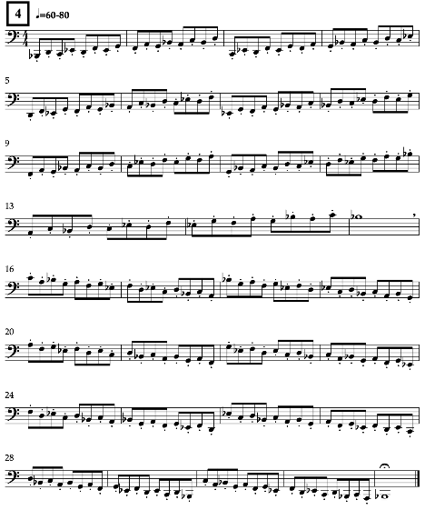

Notation Example 41. 24
Range Notation Example 4

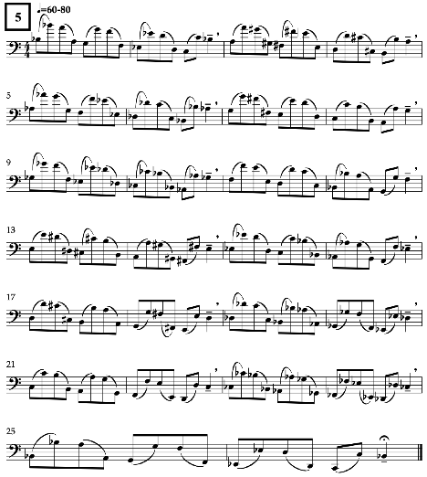

Notation Example 41. 25
Range Notation Example 5

